Omaha Beach VSR Instructor Notes

Introduction.

Notes (please read before proceeding):

1. The Omaha Beach Virtual Staff Ride is designed to last about 4 hours depending on how much time one uses for virtual movements and discussions during analysis questions at the end of each stand and during the Integration session. If one wishes to shorten the length of the ride, it’s recommended that you skip over or only briefly address those portions outlined in black in the text below. The material is left in the instructor notes in the event that the material addresses a specific training objective you might have developed for your participants. The instructor may also tailor the ride to address only those events that support the training objectives as well.

2. The virtual movement directions (highlighted in yellow) and terrain images provided herein are designed to guide you through the virtual terrain of the Omaha Beach area. It is recommended that the instructor(s) tasked with leading this staff ride spend some time moving through the terrain beforehand to orient themselves with key locations and routes. The directions are recommendations only and each instructor is of course free to use the terrain in such ways that maximizes the participants’ learning experience.

I. Stand List.

1. Background, Plans, and Preparations.

2. The Fight for the Beaches.

3. The Battle Moves Inland.

4. The Battle Moves Inland (Continued).

5. Integration.

II. Visuals List.

Title Slide
- Omaha Beach Orientation
- Beach Obstacles
- Shelf Obstacles-Les Moulins Draw
- Resistance Nests
- Resistance Nests, WN62
- Resistance Nests
- LVXXXIV Corps Situation, June 1944
- German Order of Battle, June 1944
- Order of Battle, 716th Infantry Division
- Order of Battle, 352nd Infantry Division
- Coast Defense Sector 2
- German Defenses, Omaha Beach East
- German Defenses, Omaha Beach West
- 352nd ID Situation
- V Corps Order of Battle, June 1944
- 1st Infantry Division (Force O) Order of Battle, 6 June 1944
- V Corps Mission Statement
- V Corps D-Day Objectives
- Combat Team 16 Assault Formation and Timeline
- Combat Team 116 Assault Formation and Timeline
- Organization for Combat, Company Assault Sections
- D-Day Planning Assumptions
- 352nd ID Initial Moves, 6 June 1944
- Naval and Aerial Bombardments, Joint Operations
- 16th Infantry Landing Plan 2nd and 3rd Battalions
- 2nd BLT, 16th Infantry Landings 0625-0900
- 3rd BLT, 16th Infantry Landings 0625-0900
- Cabourg Draw, Landings 0625-1200
- 1st BLT, 16th Infantry Landings 0700-0930
- 1st & 2nd BLT, 116th Infantry Landings 0625-0930
- C Co., 2nd Ranger Bn Landing 0640-0930
- 1st & 2nd BLT, 116th Infantry Landings 0625-0930
- 3rd BLT, 116th Infantry Landings 0730-0930
- 2nd & 5th Ranger Battalions Landings 0725-0930
- 2nd Wave Landings & Situation at Noon, 1030-1200
- Situation 1200, 6 June 1944
- Inland Objectives
- 352nd Infantry Division Reactions after H-Hour, 6 June 1944
- The Capture of Vierville, 0930-2400
- The Fighting at St. Laurent, 1000-2400
- The Fighting at Colleville, 16th Infantry Situation, 0930
- Reduction of WN64, 0930-1100
- The Fighting at Colleville, 0930-1100
- The Fighting at Colleville, 0930-1500
- The Fighting at Colleville, 1400-1800
- 352nd Infantry Division Reactions, 1400-2100
- The Fighting at Colleville, 1600-2100
- 3rd Battalion, The First Two Patrols, 1030-1300
- German Counterattack, Le Grand Hameau, 1420-1700
- The Capture of Le Grand Hameau, 1730-2400
- Situation, 2400, 6 June 1944
- US Casualties and Losses, 6 June 1944
- V Corps D-Day Objectives
- V Corps Advance to the D-Day Objective Line, 6-9 June 1944
End Title Slide

III. Administrative notes:

Yellow highlighted text refers to terrain movements on the virtual terrain.

Blue highlights refer to visual aids to be displayed from the PowerPoint visual aids package as well as when to cue the animations on the slides.

Text that is placed in black boxes is optional and/or background material that the instructor can choose to cover or not in order to keep the time of the staff ride within reason.

Stand 1
Background, Plans, and Preparations

Directions. None. Both screens will start with the Title Visual (PowerPoint slide) and no terrain.

Visual: Title Visual. Start with the title visual on both screens

Conduct standard introduction (Staff Ride process, purpose, training objectives, etc.), then transition to terrain orientation of the Omaha Beach area.

Omaha Beach Terrain Orientation.

Directions. Switch one screen over to the virtual terrain. Have the computer operator start with a view of Omaha Beach in the air, out to sea positioned about center sector (boundary between Easy Green and Easy Red beaches), and looking south toward the bluffs. Pan left and right as needed to show the entire length of the beach area.

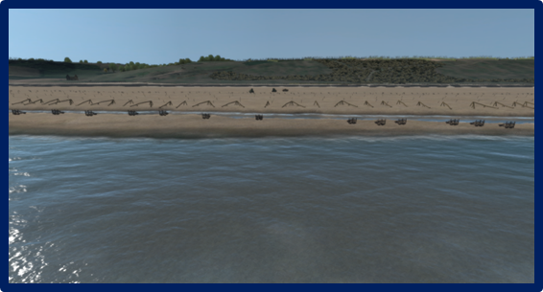

Visual: Visual #1, Omaha Beach Orientation.

Cue #1

The Beach. Omaha Beach consisted of about 8,000 meters (8 kilometers) of usable landing area.

Directions. Have the computer operator move in and descend closer to the beach to a point where you are close to the water line, still looking toward the bluffs to the south.

Cue #2

The Beach. The beach slope was very gentle in the area between the low and high tide watermarks. At low tide, roughly 0630, on D-Day there was between 300-400 meters of beach exposed. As the day wore on the amount of beach would decrease as the tide moved in. As the tide moved in, the beach obstacles would become essentially impossible to see by the Navy and Coast Guard coxswains (LCAs had British coxswains).

Directions. Have the computer operator pan left or right to view one of the runnels.

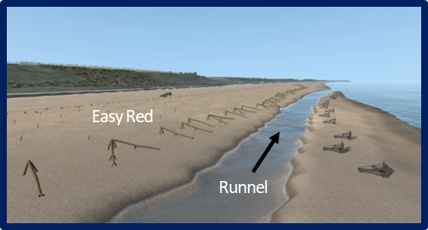
Cue #3

Runnels. At various points on Omaha Beach were “runnels.” These were natural low points in the sandy beach, something like creek beds, that were created by the swift cross current (flowing right to left facing the bluffs) in the North Sea. They were essentially long-standing pools of water at low tide, but could be much deeper than a man is tall in some places at high tide.

Cue #4

Landing Sectors. The beach was divided into 8 landing sectors (Easy Red, Dog Green, etc.), the limits of each identified by various terrain features, to provide for an orderly discharge of assault troops, vehicles, and supplies in their respective zones of advance.

Directions. Have the computer operator move forward (south) to provide a closer view of the shingle.

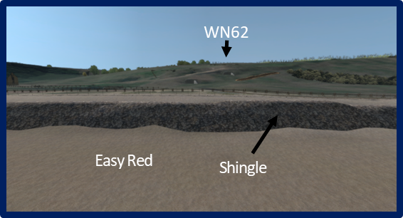

Cue #5

The Shingle. Bordering the sandy beach was a line of “shingle” (roughly fist-sized, smooth rocks). The shingle area was about 6 to 15 feet high which took on about 20-30 degree upward slope from beach to the dune line. While the shingle embankment could provide cover from direct fire, mortar rounds, artillery, and machine gun bullets could cause secondary missiles from the rocks and which could (and did) inflict additional casualties. On the eastern two-thirds of the beach (mostly, the 16th Infantry side) the shingle lay against a low sand embankment or dune line. The shingle constituted a barrier which was impassible for vehicles until engineer work could clear the way. The layers of shingle no longer exist at Omaha Beach today.

Directions. Have the computer operator slide right (west) to the Les Moulins Draw area (Exit D3) provide a closer view of the seawall.

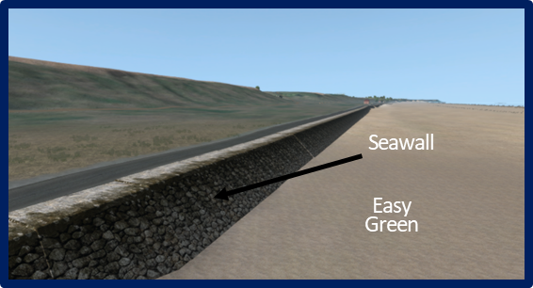

Cue #6

The Seawall. On the western portion of the beach (the 116th Infantry side), the shingle was piled near a seawall usually consisting of stone masonry sloping seaward. The seawall started near the Vierville Draw, Exit D1 and varied from 4-12 feet in height as it ran eastward to the Les Moulins Draw.

Directions. Have the computer operator slide farther right (west) to the breakwaters west of Les Moulins Draw (exit D3).

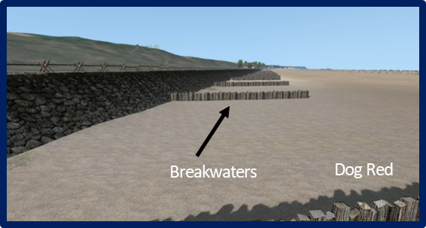

Cue #7

Breakwaters. In some areas, most notably at Exit D1 (Vierville Draw) and near Exit D3 (Les Moulins Draw), were series of wood pilings forming breakwaters along the seawall which could be used by troops for shelter, but also hindered movement to the left and right along the seawall.

Directions. Have the computer operator pan left and right to view the paved and unpaved sections of the Promenade Road.

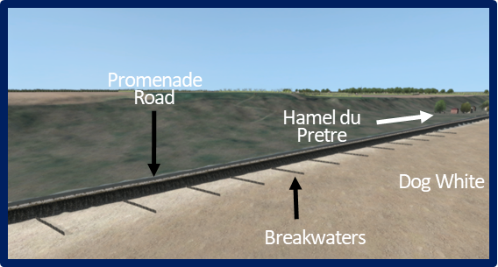

Cue #8

Promenade Road. Immediately behind the sea wall/embankment was a paved beach road that ran from Exit D1 (Vierville Draw) to Exit D3 (les Moulins Draw). From there it turned into a dirt track and extended eastward down to Exit E3 (Colleville Draw) where it again became an improved dirt road which proceeded up the draw.

Directions. Have the computer operator pan left and right to view the shelf areas beyond the seawall/shingles.

Cue #9

The Shelf. The shelf itself was typically about 200 yards wide from the shingle/seawall to the foot of the bluffs. It was mostly grassy, some of it was high grass, but mostly sparse areas with clusters of bushes and few trees. The were some areas with stands of trees but they were few. Most had been cut by the Germans for use in the obstacles and other defense structures.

Have the computer operator pan towards the Vierville Draw area to the demolished building foundations then move to Les Moulins Draw to view "Les Sables d’ Or,” and other structures

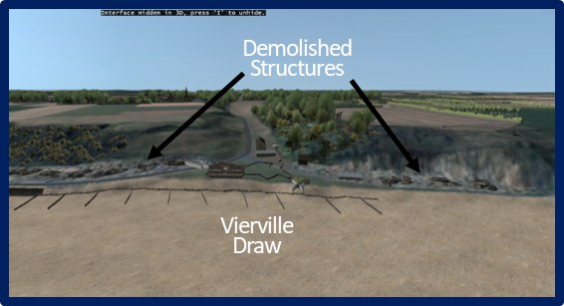

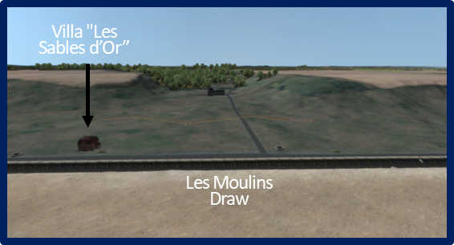

Structures on the Shelf. Most of the civilian structures located on the “shelf” (the area between the embankment/seawall and the foot of the bluffs) had been demolished by the Germans to clear fields of fire for their weapons. There were still a few structures remaining however, that the Germans used for observation platforms, defense positions, shelter and feeding sites, or were located where it was unnecessary to take them down. Most of the latter structures were several houses located between the D1 and D3 Exits (“Hamel du Pretre”). Another was the Villa "Les Sables d’Or” (the Black and Gold Villa) on the shelf near the D3 Exit and another on the west side of the E1 Exit (Colleville Draw) located slightly in the draw itself. Many of the US assault commanders planned to use these structures, among other terrain features, as navigation guides as the assault boats approached the beach.

Directions. Have the computer operator toward pan the bluffs between Les Moulins Draw (D3 Exit) and the Vierville Draw (D1 Exit).

Cue #10

The Bluff Face and Cliffs. The bluffs themselves were between 100 and 170 feet in height rising from the shelf to dominate the whole beach area. Though somewhat steep in many places, most bluffs could be traversed by hiking, but with some difficulty on the steeper parts. The steepest area was between the D1 and D3 Exits. Farther east the rise became somewhat gentler. On both flanks of the beach were rather steep cliffs of 100 feet or higher on the west and 8-20 foot sheer cliffs on the east. Those on the west could be climbed, hand over foot, but only with great difficulty and it could be dangerous without proper climbing equipment. The bluff face was generally open and free of trees, although here and there were patches of tall brush and scrub bushes.

Directions. Have the computer operator return to a view of Omaha Beach from the air about center sector (boundary between Easy Green and Easy Red beaches) and high enough to look down on all five draws.

Cue #11

The Exits or Draws. East to west, there were five draws. These draws were the immediate objectives of the Omaha Beach landings. The draws would serve as the exits for the thousands of tanks, tank destroyers, artillery pieces, antiaircraft guns, trucks, scout cars, jeeps and other pieces of equipment and supplies needed to begin the sweep of the German Army from France. Without control of the draws, the invasion, at least at Omaha Beach, would go nowhere.

Directions. Have the computer operator move to a view of the Vierville Draw (D1 Exit) in the air from over the water looking south towards the draw and the town of Vierville.

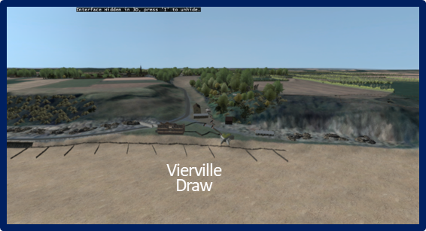

Cue #12

The D1 Exit (Vierville Draw). This was the best and most important exit at Omaha Beach. It also contained a good paved road and possessed a relatively gentle slope up to the coastal highway. It was relatively clear of vegetation, but the resistance nests defending it were also well-placed and deadly.

Directions. Have the computer operator shift left (east) to a view of the Les Moulins Draw (D3 Exit) in the air from over the water looking south towards the draw and the town of St. Laurent.

Cue #13

The D3 Exit (les Moulins Draw). Les Moulins was considered the second best exit at Omaha because it also possessed a paved road. About halfway up the draw, the road split and a dirt road led off to the right, but both roads led south to the coastal highway. The draw itself was relatively clear of vegetation.

Directions. Have the computer operator shift left (east) to a view of the St. Laurent Draw (E1 Exit) in the air from over the water looking south towards the draw and the town of St. Laurent.

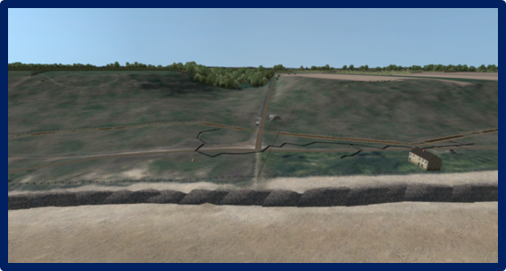

Cue #14

The E1 Exit (St. Laurent Draw). The St. Laurent Draw possessed only a small dirt trail, and was choked with trees and underbrush. It was considered the fourth best exit, but ultimately would be the first draw open on D-Day.

Directions. Have the computer operator shift left (east) to a view of the Colleville Draw (E3 Exit) in the air from over the water looking south towards the draw and the town of Colleville.

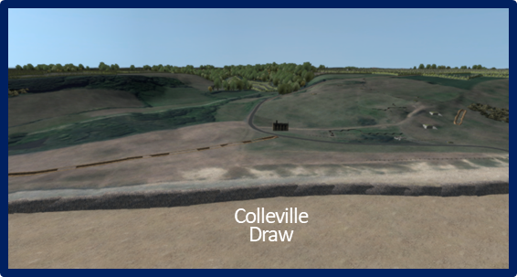

Cue #15

The E3 Exit (Colleville Draw). Colleville Draw was the largest of the five exits but possessed only an improved dirt road until it reached the coastal highway about a kilometer inland. It was a wide draw however, and possessed ample room for marshaling vehicles for movement through. Because the draw was open and wide it also provided excellent fields of fire for the defenders.

Directions. Have the computer operator shift left (east) to a view of the Cabourg Draw (F1 Exit) in the air from over the water looking south towards the draw and the village of Cabourg.

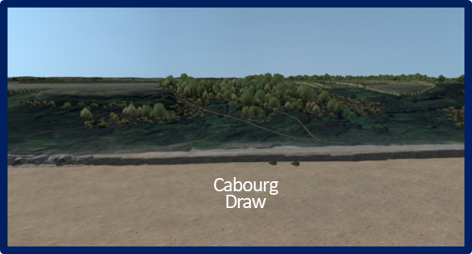

Cue #16

The F1 Exit (Cabourg Draw). Cabourg Draw was the exit farthest east. It was also the least useful and last in importance. The draw was relatively small with a small dirt track large enough for jeeps and small trucks, and it would take much engineer effort to improve it to the point where it was of much more use.

Directions. Have the computer operator shift right (west) to a view of the bluffs, fields, and hedgerows between Colleville Draw (E3 Exit) and St. Laurent Draw (E1 Exit). Remain in the air from over the water looking south towards the area between Colleville and St. Laurent.

Cue #17

The Bluff Line. At the top, the bluffs ended with a clear-cut crest line. Once on the bluff, the terrain was relatively flat but continued to rise imperceptibly for about another two kilometers inland. A massive maze of hedgerows which generally began near the lip of the bluffs spread out across the farm fields that surrounded the four main towns.

Directions. Have the computer operator pan left to right and point out the towns of le Grand Hameau, Colleville, St Laurent, and Vierville.

Cue #18

Towns of le Grand Hameau, Colleville, St Laurent, and Vierville. These towns were about 500-1000 yds inland from the bluffs. Trevieres, about 7 miles inland, was the largest town in the 1st Infantry Division’s D-Day objective area.

- German Defenses.

Visual: Visual #2, Omaha Beach Obstacles.

  - Beach Obstacles. The beach obstacles were constructed in such a way to force any invaders who landed at low tide, to traverse 300-400 yards of a wide-open beach before reaching the “safety” of the shingle. The artillery, mortars, machine guns and rockets were zeroed in on the beach area to extract maximum casualties. If the landing was attempted later, especially nearing high tide, the obstacles were designed to capsize, hang up, or rip out the bottoms of landing craft or destroy them with mines placed on the upper portions of the obstacle while negotiating the fire of the same weapons.

Directions. Have the computer operator move to the line of Belgian gates in the vicinity of WN62 to the west of the Colleville Draw (E3 Exit). Descend to sand near the waters edge to get a view of the Belgian Gates.

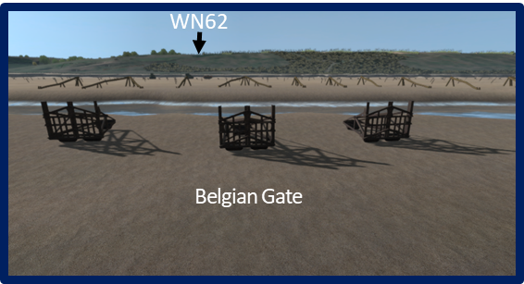

    - Belgian Gates were typically placed about 350 yards out and most contained antitank (AT) mines. (Note: The beach obstacles in this sector were emplaced somewhat closer to the high tide mark than in other sectors of the Atlantic Wall area.)

Directions. Have the computer operator move to the line of Log Ramps.

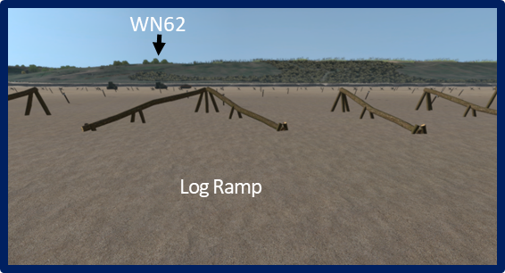

    - Log Ramps. They were built so that a landing craft that slid onto one would detonate AT mines, or if the angles were right the ramp would capsize the craft.

Directions. Have the computer operator move to the line of Log Stakes/Mined Posts.

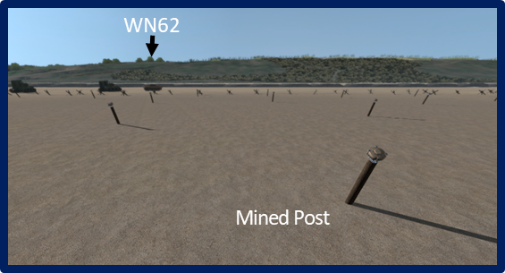

    - Log Stakes/Mined Posts. The stakes were placed beyond the Belgian Gates. They consisted of tree trunks emplaced at an angle. Some were equipped with AT mines, some without, Again the intent was to either blow up the landing craft or poke holes in the bottom of the boat.

Directions. Have the computer operator move to the line of Hedgehogs.

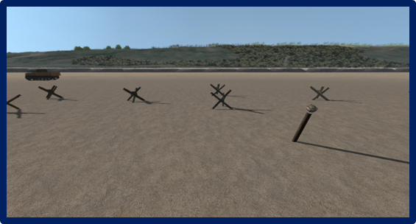

    - Hedgehogs/Tetrahedrons were generally located about the 50 to 100-yard mark. They were generally intended to rip out the bottoms of landing craft.

  - The Shelf Obstacles.

Visual: Visual #3, Omaha Beach Shelf Obstacles, Les Moulins Draw.

Directions. Have the computer operator move to a position just above the seawall so that the apron wire and concertina obstacles can clearly be seen.

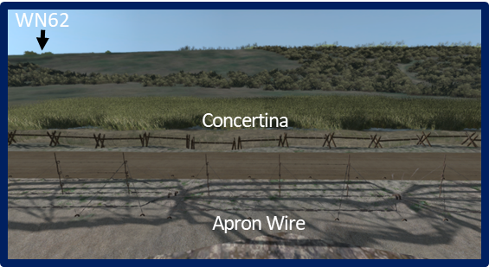

    - Concertina/Apron wire. The apron wire was typically the first obstacle beyond the embankment/seawall. It was placed between the embankment and the beach road. Typically, at least one, sometimes more, layers of concertina was placed on the other side of the road.

Directions. Have the computer operator focus on the flats behind the concertina wire.

    - Minefields (AT and AP). Beyond the bands of wire, the defenders placed antipersonnel (AP) and AT mine fields. The AP mines were generally placed in areas were the Germans expected infantry to land. AT minefield were generally placed in areas to the flanks of the Antitank Ditches and Walls. All minefields were designed to channel invasion troops and vehicles into open kill zones.

Directions. Have the computer operator move right (west) to view the AT ditches in front of Les Moulins Draw.

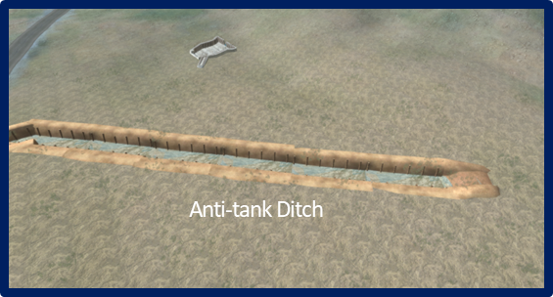

    - Antitank Ditches. There were three major antitank ditch obstacles. One in front of the E3 Exit (Colleville Draw), a second in front of the E1 Exit (St. Laurent Draw), and the third in front of the D1 Exit (les Moulins Draw). These were designed to prevent tanks and other combat vehicles from driving quickly through the draws and getting in behind the resistance nests.

Directions. Have the computer operator move farther into the draw to view the AT walls there.

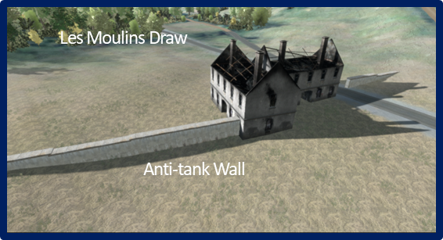

    - Antitank Walls. There were two antitank wall obstacles. The first (also the largest and most complex) was at the D3 Exit (les Moulins Draw). The other was at D1 Exit (Vierville Draw). The AT walls were about 9 feet high and 6 feet thick. The wall at Vierville Draw was about 125 feet long. The wall at les Moulins Draw was composed of at least two sections, each about the same length as that at Vierville. Though they were constructed of concrete, the Germans failed to use much in the way of reinforcement (rebar, etc.), so the walls were relatively easy to destroy once explosives were placed.

Visual: Visual #4, Resistance Nests.

Directions. Have the computer operator move to WN 60. Note: This begins the general overflight of WN locations. The intent of this orientation is not to show every fighting position, but to provide an overview of the type and location of positions in the resistance nests. Only WN62 should be covered in detail. If time does not allow, conduct only a brief overhead view of the resistance nest locations except for the detailed visits to WN62, WN72, and WN73 outlined below.

  - Resistance Nests Overview. There was a total of 14 Wiederstandnest, or “Resistance Nests” in the Omaha Beach area. Twelve resistance nests were on or above the beach. There 2 others farther inland that will be addressed later.

    - WN60. Move to WN60 and provide a quick aerial view of the position’s defenses. Move to the ground near the 76.2 mm casemates looking EDown the Cabourg Draw.This gives the participant a good idea of the German defensive viewpoint.

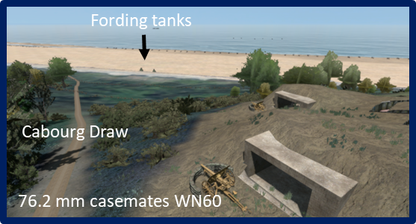

    - WN61. Move to WN61 and provide a quick aerial view of the position’s defenses. Point out the R677 casemate with the PAK88 gun.

Visual: Visual #5, WN62 Tour.

    - WN62. Move to WN62 and provide a quick aerial view of the position’s defenses. WN62 was the most well-prepared and heavily defended resistance nest at Omaha Beach. It possessed at least five machine guns (most only had two or sometimes three machine guns), four heavier field guns, and three mortar positions. (Conduct a detailed orientation of WN62.)

Cue #1

      - Command Post. Go into the CP bunker and see the observer’s view of the beach area. This is where LT Frerking was positioned. He was a field artillery officer who commanded the resistance nest and acted as a forward observer as well. The character “Pluskat” in the movie, The Longest Day, is loosely based on Lt Frerking. The real Major Pluskat was actually Frerking’s boss and back in the rear with the 352nd Artillery.

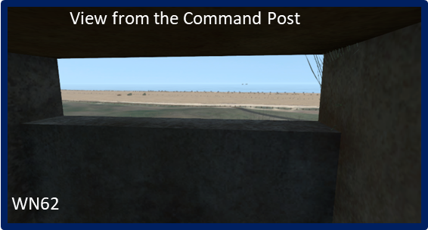

Cue #2

      - MG 42 machine gun position. Come out of the bunker and move left (east) to the MG 42 position. Move to take up a gunner’s view of the beach area and pan left and right to see what Corporal Serverloh could see in his fields of fire. This is the machine gun position of Corporal Hein Serverloh, 916th Grenadier Regiment. In his book WN62, Severloh states he fired thousands of rounds from this position and no doubt inflicted a lot of the many casualties from F Company, 16th Infantry. He was wounded and escaped from here about noon, but was captured later in the day near Colleville.

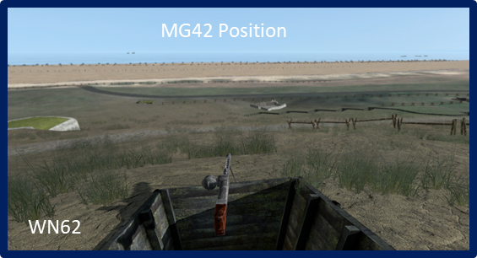

Cue #3

      - MG 34 machine gun position. Move back to the left (west) and point out the (c) MG 34 machine gun position on the other side of the CP.
Cue #4

      - 50mm Mortar Tobruk. Move left (west) to the first 50mm Mortar Tobruk. Look south down the trench line to all 3 positions. Move to the farthest Tobruk and go through the troop door to see the mounted mortar. Tobruks were concrete fighting positions designed to protect machine gunners and mortarmen. They get their name from the battle in North Africa (Tobruk) where they were first used.

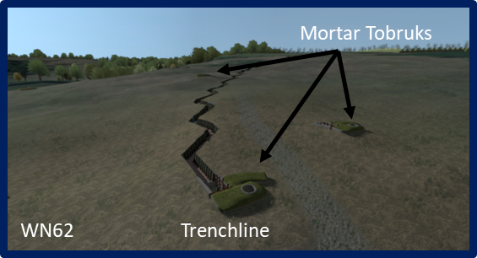

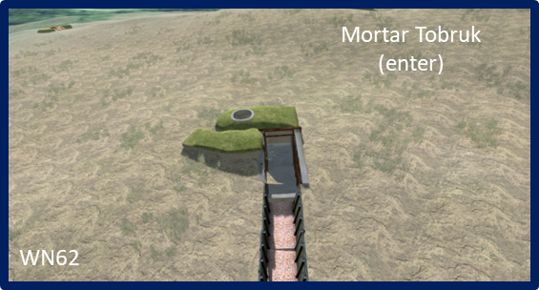

Cue #6

      - Nebelwerfer Position. Come out of the bunker and move south to the Nebelwerfer position. View the position from the air to the south of the excavated area/depression. These rockets (and those at St. Laurent) were manned by elements of the 100th Nebelwerfer Battery. Though the rockets were marginally effective in terms of accuracy, their large explosions and the screeching noise they made were very effective in making those on the receiving end to go to ground. Moreover, if one of these big rockets did land near personnel or equipment, its effects could be devastating.

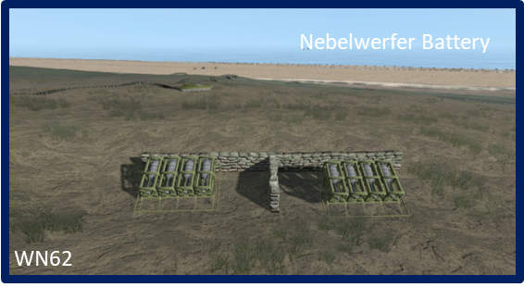

Cue #7

      - Pak 40 75mm AT Gun Position. Move east to the (g) Pak 40 75mm AT Gun Position. Move in behind the gun to see the gunner’s view towards the beach. This gun would most likely have been placed in a casement at some point. Perhaps it was intended for the incomplete casement we will see shortly.

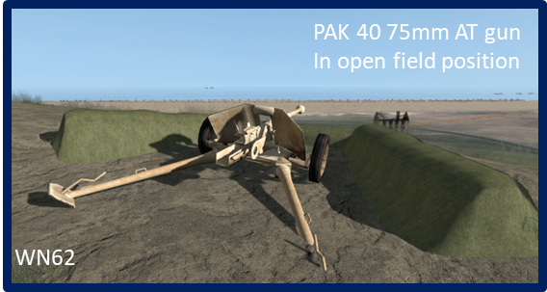

Cue #8

      - French villa/Resort Hotel. Move northeast to the French villa/resort hotel. This structure was used by the Germans as a mess hall and sleeping area. It was also used by various leaders in the 16th Infantry as a navigation reference point to verify landing zones.

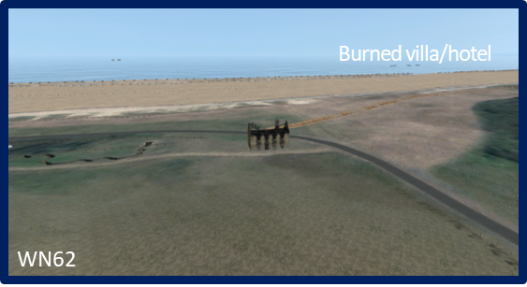
Cue #9

      - 50mm AT Gun Position. Move north to the 50mm AT gun in dug in field position. The field guns placed in the Atlantic Wall positions were a hodge-podge of foreign-made weapons, mixed with standard German issue guns. This type of gun could be found in ring mounts, pedestal mounts and casemates at various locations at Omaha Beach.

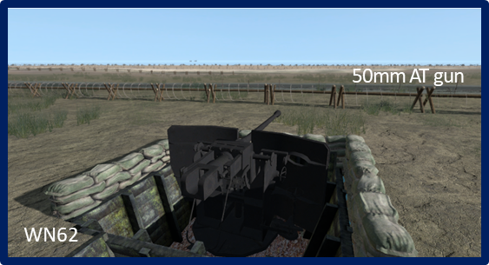

Cue #10

      - Unfinished Casemate. Point out the two MG34 machine gun positions near the 50mm AT gun. Move northwest to the unfinished casemate. There where 14 casemate positions at Omaha Beach for large caliber guns. Three were incomplete and there were several others planned but not started. The Pak 40 75mm AT Gun we saw earlier was probably destine for this casemate.

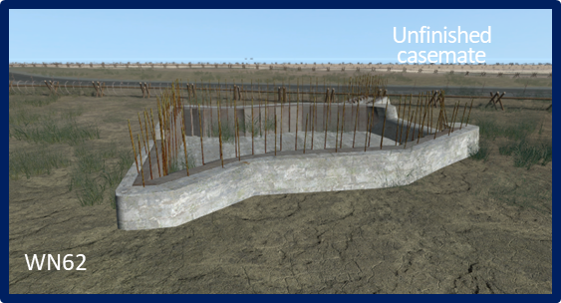

Cue #11

      - MG34 Tobruk. Move northwest downhill to the MG34 Tobruk. Move into the Tobruk through the troop door and come up behind the machine gun to take up a gunner’s view of the beach area.

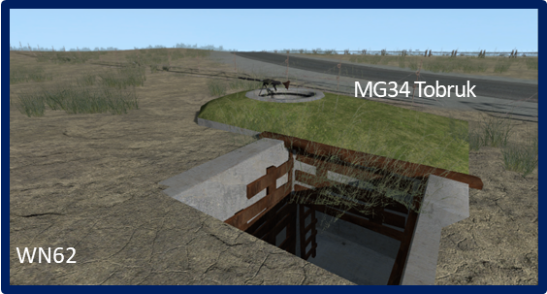

Cue #12

      - R677 Casemates. Move into the air and turn to the southwest toward the two 677 Casemates. Hover momentarily to view both positions. The casemates were positioned to have interlocking fires with other casemates on the beach. Move into the upper casemate from the rear. Look out the casemate to see the gunner’s view down the beach. Both of these casemates held Czech-made 76.5mm field guns. These are an example of weapons which the Germans impressed into service on these beaches. Others included Polish, French, and Russian guns.

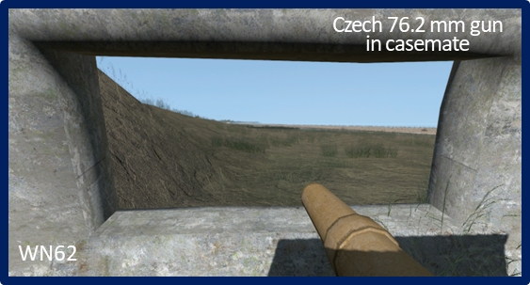

Visual: Visual #6, Resistance Nests.

(Note: If time does not allow, skip the orientation for WN 64-71. Move directly to WN 72.

    - WN64. Move to WN64 and provide a brief aerial view of the position’s defenses.

    - WN65. Move to WN65 and provide a brief aerial view of the position’s defenses. Note that this position was not fully reproduced.

    - WN66. Move to WN66 and provide a brief aerial view of the position’s defenses. Move into the Villa "Les Sables d’Or” machine gun bunker to see the gunner’s view down the beach.

    - WN67. Move to WN67 and provide a brief aerial view of the position’s defenses. Make note that this position is an example of where Rommel insisted that the main defenses be constructed closer to the beach. The defenses in WN 66 was the result. Also note that this position, along with others, was not fully reproduced due to lack of significant actions taking place there and to save digital space in the VSR database.

    - WN68. Move to WN68 and provide a brief aerial view of the position’s defenses.

    - WN70. Move to WN70 and provide a brief aerial view of the position’s defenses. Point out the area of Hamel du Pretre. Note that this position was not fully reproduced.

    - WN71. Move to WN71 and provide a brief view of the position’s defenses. Note that this position was not fully reproduced.

    - WN72. Move to WN72 and provide a brief view of the position’s defenses. Point out 677 “Casino” casemate and PAK 43 88mm AT gun. Go into the casemate through the front door, turn right an into the casemate to see the gunner’s view down the beach. The “Casino” casemate was built into the basement of the Casino Resort Hotel. It housed one of the two large PAK 43 88mm AT guns on Omaha Beach.

    - Come out and view the “Double Casemate.” The “Double Casemate” housed a PAK 40 50 mm AT Gun. The casemate was built to fire down Charlie Beach as well as Dog Green Beach. Point out the double machine gun position in the draw.

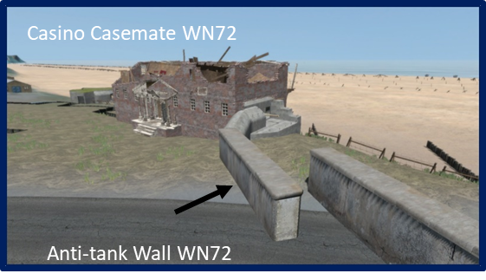
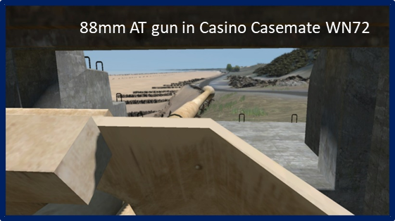

    - WN73. Move to WN73 and provide a brief view of the position’s defenses. Go into the hidden gun bunker in the cliff to see the gunner’s view down the beach. This gun was virtually undetectable for much of D-Day and inflicted a great number of casualties and damage that day.

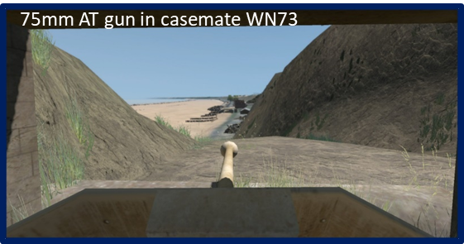

Directions. Have the computer operator return to the view of Omaha Beach in the air, out to sea positioned about center sector (boundary between Easy Green and Easy Red beaches), and looking south toward the bluffs.

    - In all, the Resistance Nests held the following weapons:

      - PAK 43, 88mm AT gun 2
      - PAK40, 75mm AT gun 3
      - PAK38, 50mm AT gun 4
      - PAK 36, 76.2 mm AT gun 2
      - 50mm AT gun, pedestal 4
      - Czech 76.5mm AT gun 5
      - 20mm Flak gun 1
      - 50mm mortar 7
      - 81mm mortar 9
      - Machine guns (MG34/MG42) 36
      - Turret Tobruks 4

Description:

Visual: Visual #7, German Situation, LXXXIV Corps.

- Background (German):

Cue #1

  - LXXXIV (84th) Corps Order of Battle-General of Artillery Erich Marcks
    - The major headquarters covering the Omaha Beach area was the LXXXIV (84th) Corps commanded by General of Artillery Erich Marcks. It was a component of the German Seventh Army and its area of responsibility included the Cotentin Peninsula and the region of Normandy over to just past Caen, or something over a 70-mile front, roughly east to west.

Visual: Visual #8, German Order of Battle, LXXXIV Corps.

    - Composition. In June of 1944, the LXXXIV Corps consisted of two mobile infantry divisions, three static (i.e. coastal defense) divisions, and other assorted corps units. (Note: The strengths stated on the slide are mostly estimates).

    - Static and Mobile Divisions. Static divisions were largely meant to man the various resistance nests along the French coast and therefore possessed little in the way of transportation assets. They also differed from standard German infantry divisions in that their two infantry regiments (normally) still possessed three battalions each. By 1944, German mobile infantry divisions still had three infantry regiments, but each regiment now possessed only two battalions. The two divisions involved in Coast Defense Sector 2 (the Omaha Beach area) were the 352nd and 716th Infantry Divisions.

Visual: Visual #9, German Order of Battle, LXXXIV Corps.

  - 716th Infantry Division. Generalleutnant Wilhelm Richter

    - Organization and Mission. The 716th Infantry Division had been the area of northern France since 1941. It was a non-mobile (static), coastal defense division composed of low caliber German troops (“old men and young boys”) and a significant number of non-German ethnic Russians, Poles, and Ukrainians. Its troops made up the majority of the defenders in the various Wiederstandnests (i.e., “Resistance Nests”) along the beach defenses from Caen to the Vire River Estuary (Grand Camp-les-Bains). Its initial mission was to prepare and defend the defenses along that part of the “Atlantic Wall.” The division's artillery, anti-tank guns, and other weapons were not the standard Wehrmacht equipment, but largely captured Polish, Czech, Russian, and French items.

Cue #1

    - 726th Grenadier Regiment. Two battalions of the division’s 726th Grenadier Regiment were the primary defenders of the resistance nests in the Omaha Beach area and they were detached to the 352nd Infantry Division in March.

Cue #2

    - “Ost” Battalions. In addition to the units of the 716th Infantry Division, there were also 3 “Ost” (or East) Battalions under the division’s control composed of non-Germans. These troops also largely manned static defense positions.

Visual: Visual #10, German Order of Battle, 352nd Infantry Division.

  - 352nd Infantry Division Generalleutnant Dietrich Kraiss

    - Organization and Mission. The 352nd Infantry Division began forming and training near St. Lo, France, in November 1943. It was composed of veteran officers and NCOs from units decimated in Russia and a large contingent of green troops and recent recruits. Its immediate mission was to train for eventual employment on the Russian Front.

Cue #1

    - Strength and Readiness. At full authorized strength, the division would have possessed about 12,769 men. Despite serious logistics and some personnel shortages, the division was declared combat ready by OKW in March 1944 (an assessment with which Kraiss disagreed). As of April 1944, it consisted of about 12,000 troops, 20 percent of which were also non-German. The division was at least 70% strength in most major weapons systems, although it was at 100 percent in artillery and possessed 26 assault guns (of 10 authorized).

Cue #2

    - As already mentioned, the 726th Grenadier Regiment, less one battalion, was attached to the division.

Visual: Visual #11, Coast Defense Sector 2.

    - Movement Forward March 1944. While in the St. Lo area, the division was detailed as Marcks’ reserve force. But on 15 March 1944, Rommel ordered Marcks to move the 352nd Division forward and have it take over the responsibility for Coast Defense Sector 2, an area that included Omaha Beach, from the 716th Division. The forward movement of the 352nd Division took place during March and April and on arrival, its troops pitched in to help build up the beach defenses.

Cue #1

    - The 914th Grenadier Regiment moved into the area between Isigny and Point du Hoc to reinforce 726th Grenadier Regiment units in that area.

Cue #2

    - COL Goth likewise moved the 916th Grenadier Regiment’s headquarters to Formigny and moved the regiment forward to reinforce the defenses between Point du Hoc and Port-en-Bessens. Allied intelligence operations failed to note this movement forward until just before D-Day when it was too late to adjust the plan in any significant way.

Cue #3

    - The division headquarters moved forward to Littry.

    - Change of Mission. With this change of mission, the 726th Grenadier Regiment (716th Infantry Division) less its second battalion, was attached to the 352nd Infantry Division. This regiment manned most of the beach defenses at Omaha with a sprinkling of soldiers from the 2/916th Grenadiers.

Cue #4

    - LXXXIV Corps Mobile Reserve. Marcks also required Kraiss to provide a mobile reserve for the LXXXIV Corps. This was Kampfgruppe Meyer which consisted of Colonel Karl Meyer’s 915th Grenadier Regiment, the 352nd Fusilier Battalion, and a detachment of the 352nd Assault Gun Battalion. As part of the LXXXIV Corps mobile reserve, Kampfgruppe Meyer was posted in the vicinity of Bayeux in the eastern part of the corps sector. For speed of movement, one of the 915th Grenadier Regiment’s battalions was equipped with French trucks and drivers. The other battalion was equipped with bicycles.

Visual: Visual #12, Omaha Beach East.

Cue #1

    - Omaha East Sector. The 2/916th Grenadiers was the 352nd Infantry Division unit directly responsible for Omaha Beach. On the east side (CT16’s sector), the battalion controlled four infantry companies manning positions in or just behind the resistance nests.

Cue #2

    - A battery of 105mm guns from the 352nd Artillery supported this sector.

Cue #3

    - The battalion kept an additional two companies in reserve at Formigny.

Visual: Visual #13, Omaha Beach West.

Cue #1

    - Omaha West Sector. The unit directly in charge of the beach defenses in Coast Defense Sector 2 was the 2nd Battalion, 716th Infantry. On the west, or CT116’s sector of Omaha, was another three infantry companies.

Cue #2

    - The sector also included another battery of 105mm guns.

Cue #3

    - In addition, there was Nebelwerfer battery of 30 launchers in WN69 and in both sectors a series of semi-prepared defensive positions in the surrounding hedgerows, St. Laurent, and Colleville.

    - Improvement of the Beach Obstacles. On 9 April Rommel made an initial inspection of the beaches and quickly ordered that the main defenses be built on the beach and as close to the beach as possible. Kraiss also began to establish a second line of defenses about 10 kilometers inland as well. Most of the beach obstacles present at Omaha on 6 June, along with 11,000 mines, had been emplaced there between 9 April and 6 June.

Visual: Visual #14, 352nd ID Situation, 4-5 June 1944.

  - Marcks’ and Kraiss’ Preliminary Actions.

    - Intelligence. Rommel and Marck’s both noted an increase in Allied reconnaissance flights over Normandy. Marcks also noticed an increase in carrier pigeon traffic used by the FFI. Sometime in May, Kraiss received intel from a captured Maquis agent that the Allies planned to invade in early June. Marcks and Kraiss were convinced the information was accurate. It’s worth noting here that once the 352nd Infantry Division moved close to the beach in April, Allied intelligence did not pick up on that fact until a few days before the invasion. None of the 1st Infantry Division planners were provided that information before D-Day. Thus, the 1st Infantry Division would be attacking into a German force about twice as strong as they had planned for.

    - 352nd Infantry Division Goes on Alert. Kraiss, with Marcks’ tacit approval, ordered a “practice” alert on the evening of 4 June ostensibly as part of an ongoing Seventh Army exercise. Because he believed the invasion was imminent, Kraiss remained at the division HQ in Littry rather than going in to St. Lo to participate in the exercise.

Cue #1

    - Additionally, Kraiss ordered Goth to move the 916th Grenadier Regiment to its field positions within 1 kilometer of the beaches and directed that all reserve ammunition be issued.

    - With Marcks’ approval, on the evening of 5 June, Kraiss requested the division commanders of the 709th and 716th Static Divisions go on actual alert as part of the exercise. Both division commanders refused.

- Background (American):

Visual: Visual #15, US Order of Battle, V Corps.

Cue #1

  - V Corps Order of Battle-MG Leonard T. Gerow
    - The V US Corps, commanded by MG Leonard T. Gerow, was the major command in charge of the Omaha Beach landing. The corps consisted of about 56,000 troops organized into:

Cue #2
        - 3 infantry divisions

Cue #3

        - A Provisional Ranger Group (2nd and 5th Ranger Battalions)

Cue #4
        - The Special Engineer Task Force (Gap Assault Teams)

Cue #5
        - 5th and 6th Engineer Special Brigades (Prepare the exits for traffic)

        - Assorted other corps troops (not all of them listed here).

Visual: Visual #16, Force “O,” Omaha Beach.

Cue #1

    - 1st Infantry Division – Force “O” The 1st Infantry Division, commanded by MG Clarence R. Huebner, was the assault force for Omaha Beach on D-Day. It was task organized and significantly reinforced for the assault mission and designated as “Force O.”

Cue #2

    - Attached and Detached Units. For D-day, the 1st Infantry Division reorganized its regiments into the “Combat Team” configuration. This was similar to the Regimental Combat Team concept of the time, at least at the regimental level (technically, a Regimental Combat Team was a non-divisional organization). For the mission, the division received the 116th Combat Team from the 29th Infantry Division.

Cue #3

    - The 26th Combat Team, a 1st Division unit, was attached to the 29th Infantry Division. The notion was that as the two assault regiments moved inland, at some point a division boundary would be established between CT16 and CT116 and the latter unit would come back under the command of the 29th Infantry Division when its command post was ashore and ready to assume control of operations. Additional attached units included:

Cue #4
      - 741st and 743rd Tank Battalions (2 companies each of DD tanks; 1 each company of fording tanks)

Cue #5

      - 58th and 62nd Armored Field Artillery Battalions (105mm)

Cue #6

      - 20th and 112th Engineer Battalions (Gap Assault Teams)

Cue #7
      - 81st Chemical Mortar Battalion (functioning as a standard mortar unit)

Cue #8
      - 5th and 6th Engineer Special Brigades (3 battalions each)

Cue #9
      - Provisional Ranger Group (initially attached to CT116)
Force A (D, E, F/2nd Rangers)
Force B (C/2nd Rangers)
Force C (A & B/2nd Ranger Battalion and 5th Ranger Battalion)

- The V Corps Plan. V Corps Mission Statement, 26 March 1944:

Visual: Visual #17, V Corps Mission Statement.

Cue #1

“The V Corps, consisting of the 1st, 2nd and 29th Infantry Divisions, with the 2nd and 5th Ranger Battalions and other forces attached, will assault Beach “OMAHA”, reduce enemy resistance, secure VIERVILLE-SUR-MER, COLLEVILLE-SUR-MER beachhead and advance southward towards ST. LO to cover the landing of other troops and supplies of the First United States Army. The rate of advance will be in conformity with the advance of the Second British Army and instructions by Headquarters, V Corps, at the time.” (The Adjutant General’s Office, WWII Operations Reports, 1940-1948, Box 24378, File #664 &665)

Visual: Visual #18, V Corps D-Day Objectives.

- V Corps D-Day Objectives.

Cue #1
    - Force A (D, E, F/2nd Rangers)(LTC James E. Rudder). Destroy enemy coast defense batteries at Point du Hoc.

Cue #2
    - Force B (C/2nd Rangers) (Captain Ralph E. Goranson). Destroy enemy coast defenses at Pointe et Roz de la Percée; move west to link up with Force A at Point du Hoc. Force C (5th Ranger Battalion, A & B/2nd Ranger Battalion) (LTC Max F. Schneider). On order reinforce Force A at Point du Hoc; depending on success at Point du Hoc, land there; or if Force A failed; land at Dog Green Beach (vic Vierville Draw). Move west to link up with Force A at Point du Hoc.

Cue #3

    - Once assembled, the Provisional Ranger Brigade move to secure the D-Day Phase line vicinity of Gefosse-Fontenay-Isigny. Orient west toward the Vire River.

Cue #4
    - CT 116 (COL Charles D. Canham) will assault the west side of the beach with two battalion landing teams (BLT), later followed by one BLT. Seize and clear Exits D3 and D1.

Cue #5
    - 1st Battalion, 116th Infantry. Drive west, link up with Force A (D, E, F/2nd Rangers) and move to secure the D-Day Phase line vicinity of Gefosse-Fontenay. Orient west toward the Vire River.

Cue #6
    - 2nd Battalion, 116th Infantry. Move to the vicinity of Louvieres – Vacqueville and secure the Beachhead Maintenance Line.

Cue #7
    - CT16 (COL George A. Taylor) will assault the east side of the beach with two battalion landing teams (BLT), later followed by one BLT. Seize and clear Exits F1, E3, and E1.

Cue #8
    - 2nd Battalion, 16th Infantry. move to vicinity south of Colleville, vicinity Surrain, and secure the Beachhead Maintenance Line.

Cue #9
    - 3rd Battalion, 16th Infantry. Move to vicinity of Huppain and make contact with the 231st Brigade, 50th Northumberland Division and . . .

Cue #10
. . . secure the Beachhead Maintenance Line. The additional follow-on forces of the V Corps would marshal in assembly areas there to prepare for future operations.

Cue #11
    - 3rd Battalion, 116th Infantry. Move to secure the D-Day Phase line on the high ground vicinity of la Cambe.

Cue #12
    - 1st Battalion, 16th Infantry. Move to vicinity Egranville/high ground north of Formigny to secure the D-Day Phase Line.

Cue #13
    - CT 18 will pass through CT 16 and move to secure the D-Day Phase line on the high ground east of Travieres. BP to assume 16th Infantry’s reserve battalion (1/16) mission.

Cue #14
    - CT 26 will pass through CT 16 and move to secure the D-Day Phase line on the high ground east of Tour-en-Bessen. Orient east toward Bayeaux.

Cue #15
    - CT115 initially the corps floating reserve. Pass through 2/116 to secure the high ground vic Longueville. BP to assist in the capture of Isigny.

Cue #16
    - 1st Division clear the shoreline in zone of action and secure D-day phase line by two hours before dark.

Cue #17

    - The 29th Infantry Division (“Force B”) Mission and Plan. Land on order of CG, V Corps. Assume control of CT 115 and CT 116 on order. Complete mop up operations in the beachhead area and defend right (west) side of corps zone. The 2nd Infantry Division arrive on D+1 as build up forces.

- Assault Plan and Timeline (schematic).

Visual: Visual #19, Combat Team 16 Assault Formation and Timeline.

Legend:

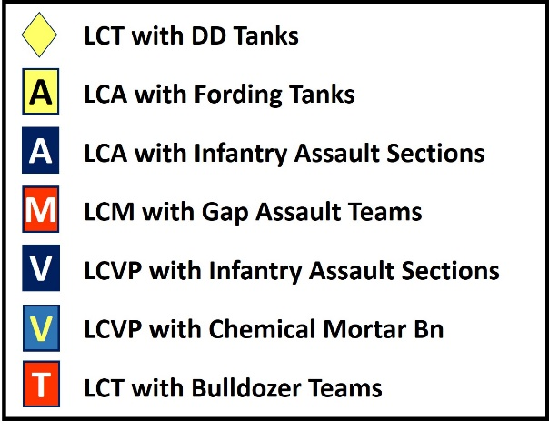

  - 0630 CT16 lands two BLT (2 companies) abreast (3rd and 2nd Battalions) on Fox Green and Easy Red respectively, followed by:
    - DD tanks
    - Gap Assault Teams
    - Third rifle and the weapons companies
    - 2 chemical mortar companies
    - Engineer bulldozer teams
    - 0730 3rd BLT lands

Visual: Visual #20, Combat Team 116 Assault Formation and Timeline.

  - Concurrently, CT116 lands two BLTs abreast (2nd and 1st Battalions)
    - 1st Battalion lands four companies in column on Dog Green
    - 2nd Battalion lands three companies abreast on Dog White, Dog Red, and Easy Green
    - DD Tanks concentrated on Dog White and Dog Green
    - Gap Assault Teams
    - 2nd Battalion weapons company on Dog Red
    - Engineer bulldozer teams
    - 3rd Battalion lands three companies abreast on Dog White, Dog Red, and Easy Green

Cue #1

  - 0930 18th Infantry begins landing
  - 0930-u/c additional units and vehicles.
  - 2000 D-Day Phase Line secured.

- Composition of an assault team.

Visual: Visual #21, Company Assault Sections.

  - The infantry companies of 16th and 116th Combat Teams were not organized as standard TOE units for D-Day. Instead of three rifle platoons and a weapons platoon, each company consisted of six assault sections. Each section was assigned to an LCVP (US) or LCA (British) landing craft.

  - Each infantry assault team consisted of about 30-33 men. A typical team consisted of:

    - 8 riflemen
    - 4-man demolition team
    - 4-man Bangalore torpedo team
    - 4-man 60mm mortar section
    - 4-man .30 cal machine gun team
    - 4-man bazooka team
    - 4-man flamethrower team
    - 1 medic

Cue #1

  - In addition to the six assault sections, each company possessed two more LCVPs which came in later in the day. One of these boats included the company supply clerks, cooks, additional medics, jeep drivers, etc. The second boat consisted of a complete “Overstrength” assault team which were really replacements to be plugged in later in the day to replace company losses.

Visual: Visual #22, D-Day Planning Assumptions.

- The Planning Assumptions. There were several reasons the Neptune planners believed that the landings at Omaha were worth the risk:

Cue #1

  - Aerial Bombardment. The Air Force would pummel the beaches with bombs and destroy many of the local defense positions located there, as well as provide craters for the infantry to shelter in and fight from.

Cue #2

  - Naval bombardment. The naval bombardment, particularly that of the LST rocket ships, would add greatly to the destruction of the enemy defenses. Between the aerial bombardment and the naval effort, the assault teams would simply walk through the beach, up the draws, and move inland.

Cue #3

  - Gap Assault Teams. The Gap Assault Teams would quickly clear away many of the beach obstacles providing clear lanes and easier access for follow on forces.

Cue #4

  - DD Tanks. The appearance of so many DD tanks and soon after, the fording tanks, would surprise and overwhelm many of the remaining defenses.

Cue #5

  - Second-rate Defenders. The beach defenses were manned by second-rate troops of the 716th Infantry Division.

Cue #6

  - Defenses-One Reinforced Battalion. The planners expected the beach to be defended by one battalion with some reinforcement. (The presence of the 352nd Infantry Division was unknown by planners until it was too late to do much about it.).

Cue #7

  - Landing Schedule. Landings would take place on time and on-target.

Cue #8

  - Massive Numbers. The quantity of men schedules to land at Omaha (40,000) would be overwhelming.

Cue #9

As events transpired, only the last assumption would turn out to be accurate.

Analysis:

- In your area of expertise (e.g. infantry, artillery, engineer, medical, etc.) what are your concerns toward successful mission accomplishment when you view the Omaha Beach area terrain and the German defenses?

- What is your assessment of the German defensive plans for Omaha Beach?

Consider the time and resources assigned to the sector’s development from November 1943 to June 1944.

- Joint Publication 3-18 Joint Forcible Entry Operations, Chapter 3, discusses course
of action development. Phase I (of 5 phases) focuses on preparation and deployment and, among others, provides these three considerations for planning:

  - Determine deployment sequencing of forces that supports gaining access
into the objective area, the initial assault, reinforcement, and the introduction of follow-on forces.

  - Determine requirements for local air and maritime superiority to conduct
the forcible entry operation.

In light of what you now know, what is your assessment of the Allied plan for the landing at Omaha Beach in relation to current Joint Forcible Entry Operations? Consider combined and joint aspects of the plan, as well as the V Corps plan itself.

Stand 2
The Fight for the Beaches

- Execution. (Preparatory fires to initial penetrations to the bluff).

Visual: Visual #23, 352nd Infantry Division Initial Moves.

  - Kraiss’ Initial Reactions to the Airborne Landings.

Cue #1

    - 352nd Division Goes to Stage II Alert. About 0100, 6 June, the LVXXXIV Corps duty officer called the 352nd Division chief of staff at Littry and told him that enemy paratroopers had been reported in the vicinity of Carentan. The duty officer ordered the 352nd to go to “Stage II” alert.

Cue #2

    - 914th GR Engages 101st AB Div elements near Carentan. Not long after, the commander of the 914th Grenadier Regiment, LTC Ernst Heyna, called and reported that his men were engaging paratroopers in the vicinity of the Carentan Canal.

Cue #3

    - Kraiss Moves KG Meyer West. Based on these reports, Kraiss ordered the 352nd Pioneer Battalion to move to Isigny to reinforce the 914th elements there.

Cues #4 & 5

    - Kraiss also ordered KG Meyer (915th GR & 352nd Fusiliers) to begin movement west to through the Cerisy Forest to St. Jean de Haye. Kraiss did not have permission to move the corps reserve, but he wanted KG Meyer to be in a more central position to support against the Carentan area airborne incursion or the beaches as needed. After ordering Meyer to head west, Kraiss directed Meyer to confer with him in person at the 352nd Division’s headquarters in Littry in case the phone was bugged.

Cue #6

    - Meyer Meets with Kraiss. About 0300 Meyer arrived at Littry to confer with Kraiss. He told the division commander that KG Meyer was en route to St Jean de Haye, but it would arrive piecemeal due to the truck/bicycle transportation configuration. At Littry, Meyer was given a special radio frequency to conduct any future communications in case OKW might be monitoring their radio traffic.
Cue #7

    - 916th Grenadier Regiment Moves Closer to the Beach. About 0500 coastal positions, including WN62 at Omaha, began reporting the arrival of the invasion armada offshore. Goth ordered the 916th Grenadier Regiment’s mobile elements forward to field locations nearer the beach.

  - US Preparation Fires.

Visual: Visual #24, Naval and Aerial Bombardments.

    - Arrival and Loading the Landing Craft. At 0250 hours on 6 June, US Navy Task Force O arrived in the transport area 12 kilometers offshore from Omaha Beach and immediately started to place hundreds of assault craft in the water, preparatory to loading them with troops and equipment. The weather was rainy and misty and the winds were kicking up substantial waves as the troops loaded their landing craft.

    - Naval Bombardment. At 0550, the naval bombardment commenced. Due to the poor visibility, the 40-minute barrage accomplished little in the way of damage to the German defenses which were essentially invisible from the sea. Even the 9 LST rocket ships which moved much closer to shore failed to do much, if any, damage. Only one of the vessels actually put rockets into its target area ashore. The missiles from the other vessels harmlessly fell short into the sea. The major contribution of the “bombardment” during this phase of the operation was merely the false courage and hope provided to the nervous soldiers sailing toward the beach as the big guns flashed and thundered, but not much else.

    - Aerial Bombardment. The expected aerial bombardment scheduled for 0600 failed as well. Again, due to poor visibility, the 400 Eighth Air Force B-24 Liberator bombers assigned to blast the Omaha Beach defenses dropped their 1200 tons of bombs 3 miles inland. In short, the bombs and naval shells which were supposed to put a dent in the German defenses and provide craters for the assault teams to use for cover never materialized.

  - 16th Infantry Landing Plan for the 2nd and 3rd Battalions

Visual: Visual #25, 16th Infantry Landing Plan for the 2nd and 3rd Battalions.

Directions. Have the computer operator ascend to a point above WN62 looking north (towards the water). Take up a view that includes Easy Red and Fox Green.

    - According to the landing plan, Combat Team 16 would land E and F Companies of the 2nd Battalion on Easy Red at about 0630, followed by G Company at 0700. Concurrently, L and I Companies would land on Fox Green followed by K Company. All British and US landing craft coxswains had been briefed on the strong rip tide that would push the landing craft off course to the east unless there was compensation for the flow. Unfortunately, many coxswains apparently did not make any effort to compensate for this phenomenon.

Cue #1

    - As events transpired, E and F Companies would land directly in front of WNs 61 and 62 on Fox Green.

Cue #2

    - G Company, however, would land on Easy Red near the “Roman Ruins”

Directions. Have the computer operator pan right toward the low cliffs at WN60.

Cue #3

    - L Company would land behind the low cliffs near WN60.

Cue #4

    - All six assault sections of E Company, CT116 would land at Fox Green about the same time as L Company.

Cue #5

    - I Company was way off course and approached the shore near Port-en-Bessin, 4 km to the east. The company would have to turn west and would land at Fox Green about an hour later.

Cue #6

    - K Company would land at Fox Green about on target.

Visual: Visual #26, 2nd BLT, 16th Infantry, 0625-0900.

Directions. Have the computer operator move over the water east. Face toward Fox Green beach and descend to just above and to the left of the LCM carrying the DD tanks. Focus on the LCM and the two DDs in the water.

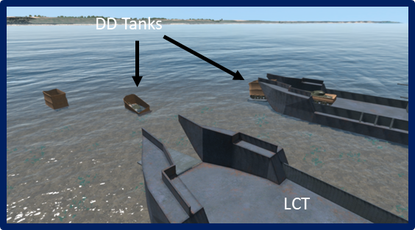

  - CT 16 Landings-2nd Battalion, LTC Herbert Hicks, Easy Red 0625-0900.

Cue #1

    - At 0625 B & C Companies, 741st Tank Battalion with 32 “Dual Drive” (DD) tanks began to launch from LCTs.
Cue #2

    - High waves caused all but 5 to sink before reaching shore.

Cue #3

    - Of the 56 DD tanks, fording tanks (A/741st), and engineer tank dozers assigned to CT 16’s side of the beach, only 16 made it to shore that morning, but those that did provided a useful base of fire that morning and knocked out several enemy positions.

Cue #4 (Tanks disappear).

Directions. Have the computer operator move forward and left (east) toward the LCAs. Move into the deck area of one of the LCAs and to see the beach through the troop doors.

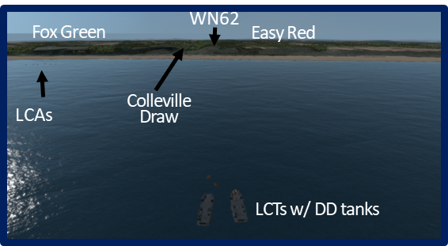

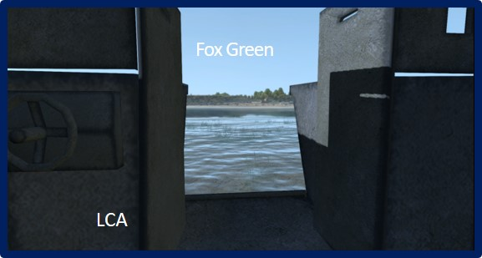

    - 2nd Battalion 1st Assault Wave Lands 0631.

Cue #5

      - E Company, CPT Edward Wozenski. The first two assault companies of the 2nd Battalion Landing Team (BLT) (E and F Companies) approached Omaha Beach right on time (0630). As they made their approach, both CPT Edward Wozenski and 1SG Lawrence Fitzsimmons of E Company knew they were not on target.

Directions. Through the troop doors, have the computer operator look toward the burned villa on the right side of the Colleville Draw (E3 Exit).
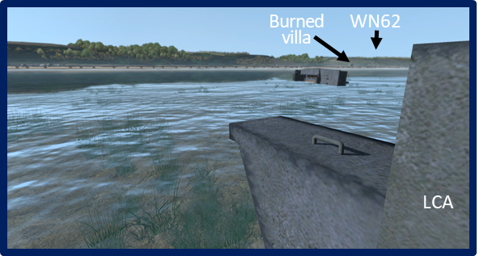

Cue #6

      - Wozenski could see the small resort villa near the mouth of the draw that he used for a navigation aid was on fire. He knew then the approach was much too far to the east (left) and would land them right in front of the draw on Fox Green, a huge open area with superb fields of fire. Fitzsimmons also saw this and tried to get the lead coxswain to swerve right and head for the correct location, but he was ignored.

Directions. Have the computer operator move through the troop doors, advance across the water to Fox Green. Halt at the beach line.

Cue #7

      - Instead, Wozenski and most of his men were unloaded in the surf about 300 yards from the shingle between WN60 and WN61. The company’s 2nd Section was unloaded in water over their heads (probably in a runnel) and some of those men drown due to their heavy equipment. The company (less the 1st Section under 2LT John Spalding which would land on target) reached the sand and moved forward, each man making his way through the obstacles as best he could. As the company moved closer to the shingle, machine gun and small arms fire increased, while larger caliber weapons focused on the DD tanks and landing craft.

Directions. Have the computer operator move through the obstacle belts and halt at the shingle at the foot of WN61.

Cue #8

      - Trying to dodge heavy fire, it took an hour for the survivors of E Company’s five sections to reach the shingle. From Wozenski’s section, only 12 of the 36 men in the boat made to the embankment unscathed. E Company would lose 105 of about 183 men who landed at 0630 that morning on the beach or at the shingle. The company lost only one man that day once the survivors made it past the bluffs. For the time being, E Company, or what was left of it, was going nowhere.

Directions. Have the computer operator ascend above Fox Green, move a short way north over the beach/water to a point where Fox Green beach, the shelf, and bluff can be viewed.

Cue #9

      - F Company, CPT John Finke. CPT John Finke’s F Company landed with and next to E Company and suffered a similar fate.

        - Three of Finke’s sections (2nd, 4th, and 5th) landed about 400 yards too far to the east with Wozenski’s men (along with four sections from E/116). Finke’s other three sections (1st, 3rd, and HQ) landed closer to the intended location, but still ended up on Fox Green directly in front of WN 62. By the time the company reached the shingle, only two of the unit’s officers had not been killed or wounded, one of whom was Finke. Later, only Finke, 1SG Ted Lombarski, and about 20 other men made it to the top of the bluffs that day. By 1400, Finke (WIA) and every officer in the company, as well as 1SG Lombarski, had been either killed or wounded.

        - As with E Company, Finke’s men were pinned down at the shingle most of the morning. Additionally, all six sections of E/116 Infantry landed among E and F Companies. Many of these men would attach themselves to elements of the 16th Infantry and fight alongside them throughout the day.

        - Having been dropped off in chest to neck-deep water (or worse) before the beach, and having to negotiate runnels en route to the shingle, many E and F Company men found their weapons clogged with sand and unable to fire once they reached cover. In many cases, the weapons hand to be field stripped and cleaned before they were functional.

Directions. Have the computer operator pan right toward the Roman ruins; move up to the shingle at the gap in the wire (next to the Bangalore box and deployed torpedo) just to the left (east of the Roman Ruins). Take up a ground view next to the box and peer through the gap generally toward the bluff.

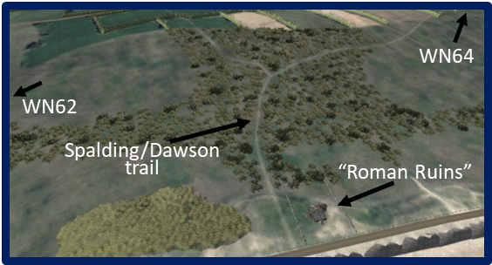

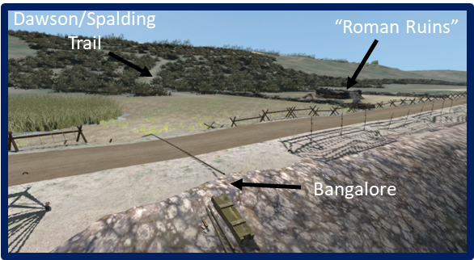

Cue #10

    - E Company, 1st Section, 2LT John Spalding. The fighting at Omaha Beach quickly devolved into a host of small unit actions lead by junior leaders. One such small unit leader on D-Day was 2LT John Spalding who was the leader for E Company’s 1st Assault Section. Unlike the rest of Wozenski’s E Company, Spalding’s coxswain somehow got separated from the other five assault sections, and ended up placing Spalding’s group about where Finke’s F Company was supposed to land – between WN62 and WN64 at 0630. The volume of direct fire was lighter here than in front of the draw (though still not light).

Cue #11

    - Even so, Spalding’s section lost 12 men between the tide line and the shingle, but by dodging through the obstacle belt in short rushes, they were able to reach the shingle in about 15 minutes. Unlike many men over in E and F Companies, the 1st Section’s weapons were all functional since the troops waded in relatively shallow water onto the beach.

Cue #12

    - The section gathered on the shingle very near a demolished homestead that became known as the “Roman Ruins.” By 0650, the section Bangalore team had emplaced its torpedoes and blew a large gap in the wire on both sides of the beach road.

Directions. Have the computer operator move through the gap in the wire and halt briefly at the Roman Ruins. Then move past the marsh to the base of the bluff.

Cue #13

    - Through the Gap. Quickly, the section charged through the gap and gathered at the ruins. From there, the section sergeant, SSG Philip Streczyk, led the team forward through an antipersonnel minefield and past a marsh to the foot of the bluffs. This was the initial penetration of the beach line on Omaha Beach.

Directions. Have the computer operator pan back north toward the Roman Ruins where G Company lands.

Cue #14

    - G Company, CPT Joe Dawson. As the main component of the 2nd Battalion’s second assault wave, the six sections of CPT Joe Dawson’s G Company landed at about 0700 just to the left of where Spalding landed. With the exception of one assault section whose boat capsized, the company landed relatively intact. Some boats were even able to put their troops directly onto the sand. Still, the company sustained a number of casualties from enemy fire before reaching the shingle, though much lighter losses than those of E and F Companies.

Cue #15

    - Dawson’s men were able to cover the 200 yards to the shingle in about 10 minutes and almost immediately began blowing gaps in the wire. Most of the company, led by Dawson, pushed right past the Roman Ruins and followed the route blazed minutes earlier by Spalding’s men.

Directions. Have the computer operator pan back toward the bluff in the direction of WN64.

    - Dawson and Spalding Meet. At about 0800, Dawson met Spalding a short way up from the base of the bluff. Dawson pointed out the strongpoint to the west that was E Company’s initial objective (WN64) and told Spalding G Company was headed up the bluff in the other direction toward WN62.

Directions. Have the computer operator pan left toward WN62. Move up the trail to the German machine gun position. Then move onto the bluff, ascend slightly so the Colleville church spire can be seen.

Cue #16

    - On to Colleville. Temporarily loaning Spalding LT Kenneth Bleau’s section to help with WN64, Dawson moved to the left (west) and headed up the bluff.

Cue #17

    - Spalding turned east and headed up as well. After encountering a German machine gun position on the bluff, which he took out with a hand grenade, Dawson, signaled his company to come forward. By about 0900, G Company, and Spalding’s 1st Section were both assembled on the bluff and moving to their objectives. Dawson headed for Colleville and Spalding headed for WN64.

Directions. Have the computer operator descend to the right (west) to view the obstacles on Easy Red.

Cue #18

    - Engineer “Gap Assault Teams.” Back at the beach, there were 8 Engineer “Gap Assault Teams” tasked to support each of the two assaulting combat teams.

      - Landing three minutes after the lead assault companies, Each Gap Assault Team was composed of 9 US Navy demolitions specialists, 27 US Army engineers from the 147th or 299th Engineer Battalions, 1 medic and 1 tank dozer. Each team was loaded in an LCM and the tanks in an LCT.

      - Each team was supposed to clear a 50-yard gap for boats and vehicles to move through.

      - The cross current before the beaches caused the gap teams to land as misoriented as the infantry in front of them.

      - The 8 Gap Assault Teams assigned to Easy Red and Fox Green suffered almost 50 percent casualties, mostly before 0900. Only Teams 9 and 10 succeeded in clearing significant gaps. On Easy Red, Team 9 cleared a 10-yard gap and another 50-yard gap.

      - Eventually, a total of 4 gaps were created between the E1 and E3 exits by the work of various teams and individual members.

Directions. From the vicinity of the left (east) side of the gap, have the computer operator pan left (east) toward the portion of Fox Green beach in front of WN62.

Cue #19

    - CT16 Advanced CP, LTC John Matthews, Lands. At 0720, the tide was already washing through the Belgian Gates and into the hedgehogs and log stakes. At this point, an LCM carrying 102 soldiers of the 16th Infantry I&R Platoon, the Regimental Advanced CP and parts of HQ Company arrived just offshore. As the I&R Platoon and others plunged into the cold, waist-deep water, German machine guns began to refocus their attention on this larger landing craft. Leading this contingent was LTC John Matthews, the regimental XO. In accordance with the doctrine of the time, Matthews was to lead the advanced CP in, establish the command post and communications with the battalion CPs, and control the actions of the combat team until the regimental commander and main CP arrived sometime later. Almost immediately after departing the LCM, Matthews was shot in the head and died instantly. Of the 102 soldiers who left the LCM, 35 were killed or wounded before reaching the shingle. The surviving CP group was pinned down along with F Company in front of WN62. Nobody was in charge of the regiment. For the time being, only the individual courage and initiative of small unit leaders and soldiers was going to ensure that some progress was being made in fighting their way off the beach.

Visual: Visual #27, 3rd BLT, 16th Infantry, 0625-0900.

  - CT 16 Landings-3rd Battalion, Fox Red/Fox Green 0625-0900.

Directions. Have the computer operator ascend and move to a point above Fox Green Beach opposite of WN60 and look south to where the beach, the shelf, and bluff can be viewed.

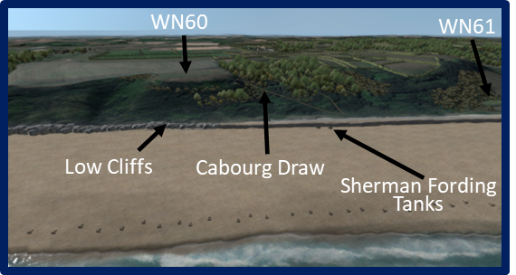

    - 3rd Battalion, LTC Charles Horner, 1st Assault Wave Lands Late.

      - I Company, CPT Kimball Richmond. Over on the eastern-most end of Omaha Beach, the troubles for the 3rd Battalion’s two lead assault companies, CPT Kimball Richmond’s I Company, and CPT John Armellino’s L Company, began before even approaching the beaches. The 3rd Battalion companies were transported in LCAs, the British version of the LCVP, and piloted by British coxswains.

Directions. Have the computer operator pan left (east) toward Port -en-Bessen.

Cue #1

      - In the mist and poor visibility, the lead coxswain for I Company became seriously misoriented and when Richmond, in the lead boat, spotted land, he soon realized that the group was at least 4000 yards too far to the east. The coxswain initially attempted to land the company near Port-en-Bessen, but Richmond refused and ordered the man to turn west and head for the proper beach. Richmond then contacted LTC Charles Horner, 3rd Battalion CO, by radio and reported the delay. Horner, in turn, radioed ahead to CPT Anthony Prucnal, CO of K Company in the second wave, to take over I Company’s initial mission (which was to reduce WN 60 and open the Cabourg Draw).

Directions. Have the computer operator pan right (south) toward the beach and low cliffs below WN-60.

Cue #2

      - L Company, CPT John Armellino. Experiencing the some of the same navigational problems as Richmond, CPT John Armellino’s L Company did not land at Fox Green until 0700, 30 minutes late. Armellino’s initial mission was to reduce WN61 but the company’s approach had it headed for the cliffs of Fox Red at the foot of the bluffs containing WN 60. Two miles off shore, the boat with the company’s 4th Assault Section capsized and 8 men drowned. The other five boats beached just shy of the Belgian Gates. The boat with 1LT Kenneth Klenk’s 1st Section was about to swamp as well and as the ramp went down and men started to unload, two rounds from the two 76mm guns in WN 60 struck the vessel killing and wounding numerous men.

Directions. Have the computer operator descend to an LCA and move to the beach. Continue moving through the obstacles to the cliffs.

      - The remaining sections unloaded into waist deep water and began the 200-yard movement to shore. Of the 187 men in L Company who approached Fox Red, only 123 made it to the cliffs without being killed, drowned, wounded, or swamped offshore (most the latter were rescued). On arrival at the cliffs, Armellino discovered a number men from E Company and E Company, CT116 (way off course) already huddled under the cliffs and extending off to the west behind the shingle.

Directions. Have the computer operator pan slightly right (west) toward WN60 and the K Company landing area below WN-60.

Cue #3

      - K Company, CPT Prucnal/1LT Frederick Brandt/1LT James Robinson/2LT Leo Stumbaugh. Remarkably, all 6 sections of CPT Anthony Prucnal’s K Company landed almost on time and in the correct location at Fox Green (to the right of L Company) five minutes later at 0705. Landing more or less intact, the company made its way through the same heavy fire encountered by Armellino’s men. Also like L Company, the men of K Company found men of from E Company and E Company, CT116 huddled behind the shingle and pinned down by enemy fire. Not long after landing, the company XO, 1LT Frederick Brandt, was struck by shrapnel from an artillery round. Prucnal ran into the open to pull his XO to safety and was likewise struck down. Both men soon died from their wounds leaving 1LT James Robinson in command. A short time later, Robinson was instantly killed by small arms fire and 2LT Leo Stumbaugh assumed command of K Company.

Visual: Visual #28, Cabourg Draw (F1 Exit).

Directions. Have the computer operator ascend slightly (@ 50 feet in the air) and take up a view of the Cabourg Draw (F1 Exit) with the end of the cliffs about center sector. Ensure the two Sherman tanks positioned between WN60 and WN61 are in view.

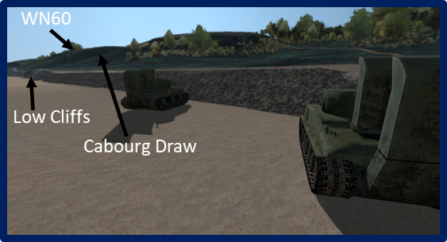

      - L Company, CPT John Armellino/1LT Robert Cutler. Once at the cliffs, Armellino began formulating a plan to assault WN60 which sat above the cliffs. The captain repeatedly exposed himself to fire to run over to a couple of A/741st Tank Battalion’s fording tanks which had made it to shore and direct their fire. On one of his trips to organize fire support for the movement, Armellino was seriously wounded and 1LT Robert Cutler assumed command of L Company. 1LT Jimmie Monteith, 2nd Section Leader, took up the role of coordinating the tanks, while Cutler began getting L Company’s assault sections organized for the movement up the Cabourg Draw (F1 Exit).

Directions. Have the computer operator move to one of the Sherman tanks and take up a gunner’s view toward WN60.

Cue #1

      - Monteith sprinted through heavy gunfire to reach the two tank commanders. After pointing out several German positions and explaining to the tank commanders what was needed to cover the company’s assault, Monteith walking in the open, guided the vehicles into position. As the tanks opened fire, knocking out at least 2 machine gun positions, Monteith sprinted back to the company.

Directions. Have the computer operator move back to the previous view.

Cue #2

      - Cutler ordered Monteith to take his section up the left side of the draw.

Cue #3

      - The 3rd Section with 5th Section attached under 2LT John Williams would advance up the right of the draw.

Cue #4

      - 2LT Kenneth Klenk’s 1st Section, now down to only 12 men, would move about 200 yards west and advance up a gulley there. Cutler, with the rest of the company would lay down a base of fire at the resistance nest, while Monteith and Williams moved out first from behind the cliffs, breached the initial wire obstacle, and proceeded up the gulley. Machine guns and mortars from newly landed M Company would help support the attack and help suppress WN60.

Directions. Have the computer operator follow Monteith’s route up the draw while looking toward WN60. Proceed through the trees and gaps in the wire obstacles until arriving at the head of the draw.

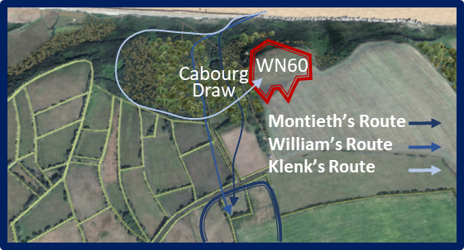

      - The Attack Up F1 Exit (Cabourg Draw). With the tanks and firing line suppressing much of the enemy’s own firepower, all proceeded, more or less, according to plan. The first two assault groups slowly shot and grenaded their way up the draw toward the high ground while at the same time picking their way through mines and wire obstacles. Fortunately, the draw was fairly covered with brush and trees which helped to obscure L Company’s movements there. Klenk’s section initially moved west along the beach and picked up two partial assault sections of E Company, 116th Infantry which had landed along the beach there. Turning south, Klenk and the others crossed the shelf and picked their way through a lightly defended gulley between WN60 and WN61.

Directions. From the head of the draw, have the computer operator follow Monteith’s route across the dirt road and to the L Company Defensive positions.

Cue #5

      - The Hasty Defense. As Monteith’s men kept up the fire into WN60 on the left, William’s group cleared away several German defenders from the head of the draw. Once on the high ground, Williams’ section made their way through yet another minefield and wire obstacle, and across an old dirt road.
Cue #6

      - On the other side of the road, Williams set up a hasty defense position and Monteith’s Section joined them there. Monteith and Williams were soon joined by Cutler with the rest of L Company and soon after that, two reduced Sections of K Company led by LT Stumbaugh, joined as well.

      - The time was about 0900 and the 2nd Battalion now held a foothold on the bluffs. It was now only a matter of additional reinforcements coming up the draw so that the “battalion” could finish reducing WN 60 and continue its mission east toward Huppain to link up with the British 50th Division.

Directions. From the L Company Defensive positions, have the computer operator move back to the head of the draw. From there follow Klenk’s route through the defensive wire belts around WN60, move to the first trench and advance down it to the turret Tobruk.

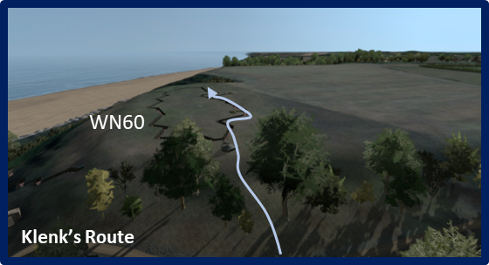

Cue #7

      - Klenk Attacks WN60. LT Klenk’s group, now reinforced with the men from E/116th, also made it to the top, and from there drifted left to link up with the rest L Company. Sometime around 1030, Klenk’s lead elements encountered the concertina protecting the south side of WN60. After trading grenades and rifle fire, Klenk’s men penetrated the wire. They soon encountered a trench line and began to systematically clear the ditch and its associated fighting positions, by the time they reached the end on the far side of WN60, they had captured 15 POWs. By about 1130, WN60 was effectively neutralized.

Cue #8
      - Klenk then turned around and linked up with the rest of L Company at the hasty defense position.

Directions. Have the computer operator ascend and move back to the L Company Defensive positions. From there, turn west and look back at the landing area below WN62/Roman Ruins.

Visual: Visual #29, 1st BLT, 16th Infantry Landings, 0730-0930.

      - The 3rd Battalion HQ Group. As all this action took place, unfortunately, the 3rd Battalion’s advanced and main CPs under MAJ Eston White and LTC Charles Horner, respectively, landed very near the Roman Ruins. Though the headquarters was now consolidated, the battalion command team was 2500 yards away from their troops and between the two groups were WN61 and WN62. 1LT Cutler was in effect the battalion commander for the time being.

Directions. Have the computer operator pan right (north) to look back at the landing area below WN60 where I Company lands.

Cue #1

      - I Company, CPT Richmond, Links Up With Cutler. Meanwhile, Richmond’s I Company was making its way back from Port-en-Bessen. En route two of the six boats swamped, though most of those men were rescued. I Company’s troubles weren’t over, however. At 0800, as the remaining four boats approached the same obstacle line where K Company had landed, Richmond’s vessel struck a mine post, now under water. Two other boats received direct hits from artillery rounds (probably fired from WN60). Only one boat managed to land its troops unhindered, except for the heavy small arms fire. As with the other companies before it, the surviving troops of I Company headed for the shingle. Once there, Richmond, who survived the mine blast unscathed, and his other leaders went to work reorganizing his command.

Cue #2

      - Receiving word about L Company’s attack through the F1 Exit, Richmond moved his men to the west and proceeded to make his way up the draw. L Company having somewhat cleared the way (although fire was still coming from WN60) Richmond moved his men through the draw to the bluff line. At around 1200, I Company made contact with Cutler’s command and Richmond became the new defacto battalion commander.

Directions. Have the computer operator move to the left (west) to a point over the bluffs south of the Roman Ruins. Form the air, take up a view of the Easy Red Beach looking north and bluff area centered on the Roman Ruins.

Cue #3

  - CT 16 Landings-1st Battalion, LTC Edward Driscoll, Easy Red 0730-0930. At 0730, LTC Edward Driscoll’s 1st Battalion began landing at Easy Red. A and B Companies came in at about the same point where Spalding’s section had landed about an hour earlier.

Cue #4

  - Five minutes later, C Company arrived at the same spot Joe Dawson’s G Company had landed. The enemy fire was still heavy, but the battalion sustained relatively few casualties compared to those of the other two battalions. Driscoll was able to move his troops through the existing gaps in the wire and his men created a few more.

Cue #5

  - By 0930, the battalion was assembled on the bluff and preparing to move inland.

Cue #6

  - Colonel George Taylor, CO CT16. At 0815, Colonel George Taylor, commanding officer of Combat Team 16, landed among the obstacles as the tide washed closer to the shingle.

Coming in at about the same spot as F Company, Taylor immediately observed the tangled mass of huddled men behind the shingle who were all that was left of F Company. Surveying the scene, Taylor saw dozens of dead men, wounded men, seasick men, wrecked vehicles, knocked out tanks, and other images which must have turned his stomach. After learning that Driscoll’s 1st Battalion was moving to the bluffs near the Roman Ruins, the colonel quickly began organizing leaders and troops of the lead assaults waves still stuck behind the shingle ordered them to move to the right to get off the beach and out of the kill zones. Proceeding through F Company and toward E Company (rather than moving west toward the gaps) the colonel encouraged, talked, ordered and threatened officers and men to get up, find a weapon if they didn’t have one, and move to the gaps. Many of the men on the beach that day recalled Taylor, sometimes standing straight up and striding down the lines of men and bodies along the shingle, shouting words to the effect of, “There are only two kinds of men who are staying on this beach; those who are dead, and those who are going to die. If we’re going to die, let’s do inland.” For many soldiers, Taylor’s words and actions were the elixir they needed to get up and get moving. After reaching the area where E Company was pinned down, Taylor turned and made his way back west. Remarkably, he made it all the way to the Roman Ruins and proceeded up the bluff without a scratch. By 1000, the Regimental CP was operational on the bluff face just above the Roman Ruins and Taylor and his staff were working to bring some semblance of order to CT16’s operations.

Note: At this point the narrative shifts to the west side of Omaha Beach in Combat Team 116’s sector. We will return to Combat Team 16’s sector later in the staff ride.

Visual: Visual #30, 1st & 2nd BLT, 116th Infantry, Landings 0625-0930.

Cue #1

Directions. Have the computer operator move west and ascend to a point above Dog Green beach. Move a short way north over the beach/water to the vicinity of the LCTs with tanks on Dog Green beach, where the tanks, the shelf, and bluff can be viewed.

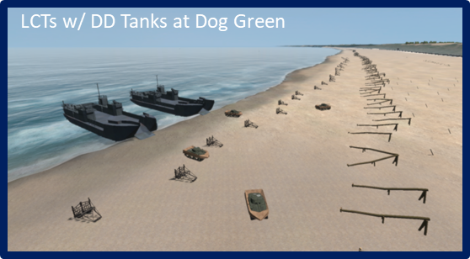

  - CT 116 Landings-1st Battalion, Dog Green 0625-0900. The plan for CT116’s landings on the west side of Omaha differed from that of the 16th.

Cue #2

  - On the right, farthest west, the 1st Battalion would land A Company on Dog Green at Vierville Draw and that company would be followed in turn by the rest of the battalion’s companies, B, D, then C in order.

Cue #3

  - On the combat team’s left, the 2nd Battalion would land with three companies abreast, with F Company on Dog White next to A Company, G Company on Dog Red in the center, and F Company on Easy Green on the left. These would be followed by A & B Companies of the 2nd Ranger Battalion, with the 5th Ranger Battalion coming in as the last of the initial waves. As with CT 16, however, the lead elements in were to be the DD tanks.

Cue #4

    - B & C Companies, 743rd Tank Battalion. The 8 LCTs, holding 32 DD tanks of the 741st Tank Battalion were to begin landing at 0625. Fortunately for the tankers in this group, the US Navy LCT group commander and the 743rd Tank Battalion commander, agreed that the sea was too rough to launch the DD tanks.

Cue #5

    - Instead, the LCTs moved up to the beach and successfully launched all 32 tanks onto the wet sand. The 116th Infantry and Rangers on the west side of Omaha would be the beneficiaries of this added firepower, although many of the tanks would eventually be knocked out before they could get off the beach.

Cue #6

    - A Company, CPT Taylor Fellers. The experience of the lead assault companies of CT 116 varied from that of those of CT 16 to the east, but if anything, for CPT Taylor Fellers A Company, 116th Infantry it was worse. Fellers’ mission was to clear and open Exit D1, the Vierville Draw. It was considered Omaha Beach’s prime objective since it provided the best exit off the beach. The German defenders were well aware of this fact as well and built three resistance nests (WN70, 71, & 72) to defend it. The three positions held no less than 11 machine guns, five 81mm mortar Tobruks, and three casemates, one each with a 50mm, a 76mm, and an 88mm antitank gun.

Directions. Have the computer operator descend and move forward toward the LCAs.

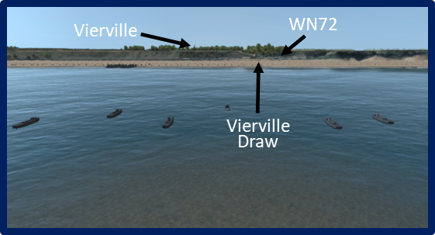

    - Loaded on 6 British LCAs, A Company approached its assigned landing beach at Dog Green on time. Two of the landing craft were lost before reaching the beach (one swamped, one from shellfire). The other four unloaded their charges into waist high water. It was a slow process since the LCA could unload only one man at a time (compared to three at a time for an LCVP). Thus far the incoming fire was a few mortar rounds.

Directions. Have the computer operator move into an LCA, through the troop door, and across the water to the beach. Move through the obstacles to the seawall near Vierville Draw.

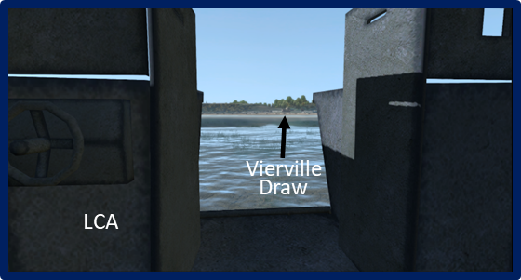

    - But as the men of Company A reached the sand, the German machine guns opened up. Within minutes, the company sustained massive casualties. Fellers was likely killed vary early. In fact, all 32 of the soldiers on Fellers’ landing craft would die that day. Of the 155 men who made it to the sand, 100 of them died in the water, on the beach, or at the shingle by the end of the day. Of the other 55, 38 were wounded.

    - B Company, CPT Ettore Zappacosta. Following on the heels of A Company, CPT Zappacosta’s B Company did not have much better luck. The LCA formation broke apart. Three sections, including Zappacosta’s boat, landed behind A Company on Fox Green and suffered a similar casualty rate. Zappacosta was killed in the water. The other three sections were spread out between Dog Red and Charlie Beach near C/2 Rangers. As a result, those sections suffered fewer casualties, but contributed little to the day’s efforts.

Cue #7

    - The survivors of A and B Companies huddled amongst the breakwaters in front of Vierville Draw. Needless to say, Vierville Draw would not be open any time soon.

Directions. Have the computer operator move to the original view in front of Dog Green.

Cue #8

    - C Company, 2nd Ranger Battalion, CPT Ralph Goranson. Soon after Fellers’ A/116 landed at Dog Green, CPT Ralph Goranson’s Company, 2nd Ranger Battalion was landing on Charlie Beach at the far west end of Omaha. Loaded on two LCAs, the 65-man company’s mission was originally scheduled to land at Vierville Draw and move through it to the high ground. From there it would move west to a promontory called Pointe de la Percee, and reduce a strongpoint located there. From there, Goranson was to proceed west to link up with the part of LTC James E. Rudder’s 2nd Battalion at Point du Hoc. If the draw was not yet cleared, the company would have to land farther west at the Charlie Beach sector, move across the shelf and scale a 100-foot cliff. In that event, the mission was similar to that of that portion of the 2nd Battalion which was to assault Point du Hoc, but Goranson’s men were not similarly equipped with the appropriate climbing equipment.

Directions. Have the computer operator descend to the right (west) and approach the cliffs in front of Charlie Beach just below WN73. Move past the two LCAs to the foot of the cliffs.

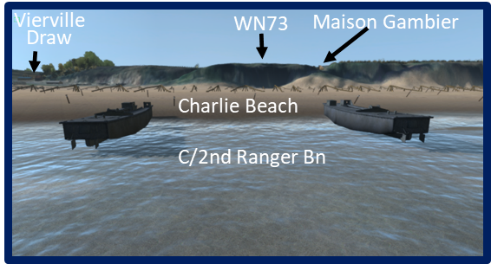

    - It was apparent to Goranson as he neared Dog Green that the Vierville Draw was not open and A and B/116 were making no progress. He ordered the LCAs to swerve right and they ended up placing the company right in front of WN73 on Beach Charlie. The company lost 12 men from direct fire on the way in and by the time it crossed the beach and reached the base of the cliffs, the company was down to no more than 35 men. Fortunately, the company faced no wire obstacles or mines in this area.

Visual: Visual #31, C Co, 2nd Ranger Bn, Landings 0640-0930.

Directions. Have the computer operator move to the right (west) and to the climbing route Move up the cliff to the top of the bluff west of the Maison Gambier ruins.

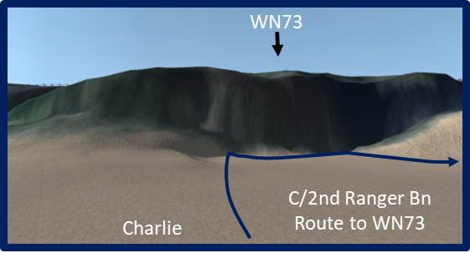

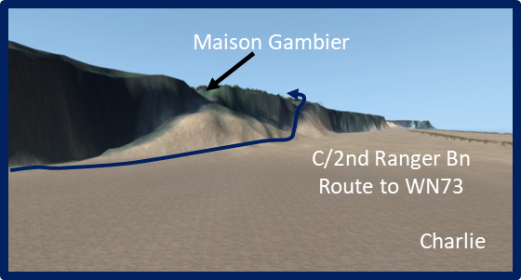

Cue #1

    - Moving west about 300 yards, the company XO, 1LT William Moody, located a climbing route to the top which appeared feasible, though dangerous. From there, the remaining men of C Company began their treacherous climb to the top.

Directions. Have the computer operator move past the Maison Gambier ruins and the barn to the hedgerow west of WN73.

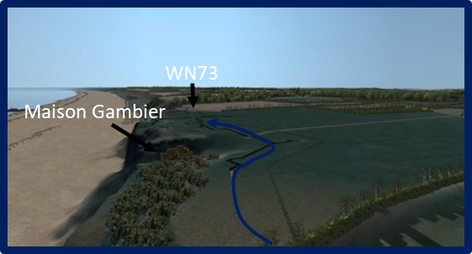

    - By 0730 Goranson and his men had climbed to the top of the cliff (making them to be first on the bluffs at Omaha) near “Maison Gambier” a once beautiful mansion situated in a cleft of the bluff which faced the North Sea. D-Day planners called it the “fortified house,” but the mansion turned out to be undefended. Given that their ascent was unopposed and having seen the carnage in the vicinity of the Vierville Draw, Goranson made the decision to turn east and attempt to take out the defenses of WN73 rather than moving toward Pointe de la Percee.

Directions. Have the computer operator move past the hedgerow to the trench line in WN73 and follow it for some distance.

Cue #2

    - Moving past a large stone barn situated behind the mansion, several Rangers in the lead discovered a trench system on the far side of a hedgerow. Moving into the trench, these men were able to take out several German defense positions including a machine nest that had inflicted numerous casualties on the company after it landed and scrambled across the rocky beach to the bluff.

Cue #3

    - The company was soon joined by a misdirected assault team from B Company, 116th Infantry. These men also began climbing the cliffs and assisted the Rangers with their work at WN73. Though they were not able to fully clear the resistance nest, their efforts substantially reduced the amount of firepower being directed at the Vierville Draw.

Visual: Visual #32, 1st & 2nd BLT, 116th Infantry Landings 0625-0930.

Directions. Have the computer operator ascend and move to Dog Green Beach. Look south towards Vierville Draw from over the water.

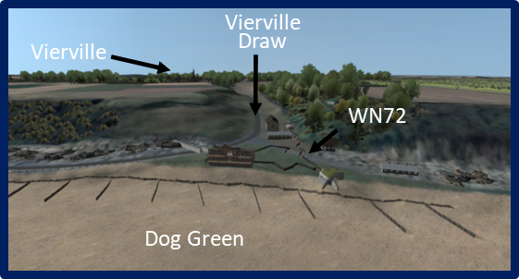

- Dog Green Beach Closed. After the heavy casualties sustained by A and B companies, at about 0720, someone (probably the commander of the US Navy assault landing force) recommended closing Dog Green Beach and to divert forces farther east to the 2nd Battalion beaches where the fire was noticeably less. The Army concurred and the rest of the 1/116 BLT would go in to the east of Dog Green where the 2nd BLT was slated to land.

Directions. Have the computer operator move east and ascend to a point above Dog Red Beach. Move a short way north over the beach/water to a point where Dog Red Beach, the shelf, and bluff can be viewed.

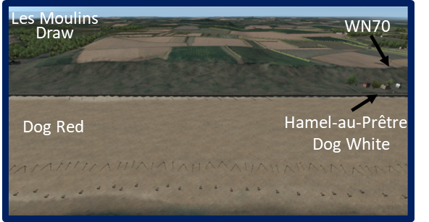

  - CT 116 Landings-2nd Battalion, Dog Red, Dog White, and Easy Green, 0625-0900.

Cue #1

The 2nd Battalion Landing Team was commanded by MAJ Sidney Bingham. Compared to the initial 1st Battalion landings, the 2nd Battalion’s landings for its assault companies went only slightly better. Unlike the 1st Battalion, the 2nd Battalion was slated to land with three rifle companies abreast.

Directions. Have the computer operator pan left (east) toward Fox Green Beach where E/116 landed (with E and F, 16th Infantry).

Cue #2

    - E Company, CPT Lawrence Madill. Already discussed briefly was the landing of CPT Lawrence Madill’s E Company. Instead of landing at Easy Green, four assault sections ended up on Fox Green with E Company, 16th Infantry, and the other two, including Madill’s, landed among F Company, 16th Infantry, at the base of WN62. Madill’s company took significant casualties on the beach and at the shingle. Madill himself was mortally wounded after reaching the shingle. During the morning, the remainder of the company’s sections gradually attached themselves to elements of the 16th Infantry and performed credible work with that combat team the rest of the day.

Directions. Have the computer operator pan back to the right (south) toward Dog Red Beach and generally toward Les Moulins Draw (D3 Exit)/WN68.

Cue #3

    - F & G Companies, CPTs William Callahan & Eccles Scott. CPT William Callahan’s F Company was supposed to land just to the west of WN 68 near Exit D3 (Les Moulins Draw). The actual landing of the company was closer to target than many that day, but instead of being west of the draw, it was dropped right in front of it.

Cue #4

    - Concurrently, CPT Eccles Scott’s G Company was landing two sections just to the left of F Company and four more right behind. There was initially very little fire as the men waded toward the beach, but as at other locations, as they reached the sand and the first row of Belgian Gates, the enemy on WN 66 and WN 68 opened fire with machine guns, small arms, and mortars. The volume was sudden and heavy, and men began to quickly drop. Still, the two companies suffered less casualties than their buddies over in the 1st Battalion at Vierville. Two factors assisted this outcome. First, the German defenders here were firing frontally. There were few defenses to the left and right of the draw that could place the kind of flanking fire which proved so deadly at Vierville Draw. Secondly, several brush fires started by explosions from artillery, rockets or naval gunfire sprang up and the smoke served to obscure the normally good fields of fire the German defenders possessed.

Directions. Have the computer operator descend to the seawall just to the east of Les Moulins Draw (D3 Exit). Remain slightly in the air and move along the seawall until reaching the last of the breakwaters. Remain focused on the breakwaters.

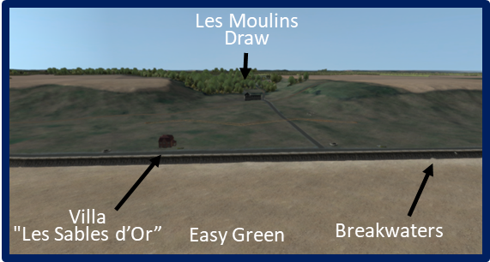

Cue #5

    - G Company. Once at the shingle, as was happening elsewhere on Omaha Beach, the company leaders struggled to organized their survivors under fire and prepare to continue the mission. In the process, CPT Williams was severely wounded, leaving G Company under the command of the XO. The XO began the process of moving the four sections over which he had control back west about 1,000 yards to Dog White beach in order to complete the company’s mission. After moving about 400 yards in 2 hours however, the company ran into a series of breakwaters along the seawall which eventually prevented any further lateral movement in that direction. G Company was stuck.

Directions. Have the computer operator pan back to the left and move along the seawall to a point near "Les Sables d’Or.”

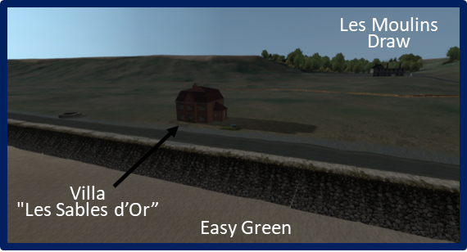

Cue #6

    - F Company. Bingham and his battalion staff landed next to the "Les Sables d’Or,” a resort villa the basement of which the Germans had turned into a pillbox. The machine gun located there was inflicting fearful casualties on the men of F Company, among whom Bingham had landed. Shocked at the dead, dying, and wounded men around him, and seeing that no one was making any effort to fight back, Bingham, part of his staff, and some junior leaders rounded up about 50 men and began an assault on the villa. After blowing holes in the concertina, and sustaining a few casualties, Bingham and his ad hoc assault team were able to make it to some dugouts and trenches near the house. It was there that most of the troops discovered that their weapons were full of sand and would not fire. Bingham set the men to cleaning their weapons while he and several others bolted and made it inside the villa. After posting men in the upper floors to act as OPs and snipers, Bingham went back out to the dugouts and get his radios working (to no avail). Though the machine gun bunker at Les Sables d’Or was apparently knocked out, Bingham’s 2nd Battalion remained completely stalled in front of and near Les Moulins Draw (Exit D3).

Visual: Visual #33, 3rd BLT, 116th Infantry Landings 0730-0930.

Directions. Have the computer operator ascend and move east to a point above Easy Green beach between WN65 and WN66. Move a short way north over the beach/water to a point where Easy Green beach, the shelf, and bluff can be viewed.

  - CT 116 Landings-3rd Battalion, Lt. Col. Lawrence E. Meeks, Easy Green & Easy Red, 0730-0900. Like the 2nd Battalion, Lt. Col. Lawrence E. Meeks’ 3rd Battalion was supposed land 3 companies abreast on Dog White, Dog Red, and Easy Green.

Cue #1

  - Fortunately for the battalion, all three companies ended up landing on Easy Green and Easy Red generally along the inter-regimental boundary with CT16 at about 0730. This had the effect of concentrating the battalion essentially halfway between WN65 and WN66. This was one of the least defended areas of Omaha Beach. In short, the battalion was able to blow gaps quickly and move to the bluff and up to the top in fairly good order and with relatively few casualties.

Cue #2

  - Most of the battalion was either moving up the bluff face, or on the bluff, by 0930.

Visual: Visual #34, 2nd & 5th Ranger Battalions Landings 0730-0930.

Directions. Have the computer operator slide west (to the right) to a point above Dog White looking toward WN70. Move a short way north over the beach/water to a point where Dog White beach, the shelf, and bluff can be viewed.

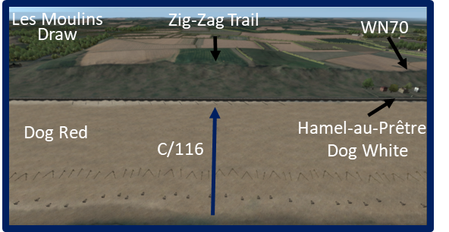

  - CT 116 Landings-C Company, 1st Battalion, Dog White, 0725-0930.

Cue #1

    - C Company, CPT Berthier Hawks. Off to the 3rd Battalion’s right, CPT Berthier Hawks C Company was landing on Dog White beach as the first beneficiary of the decision to close Fox Green. As the company moved toward the beach in column, the boat section commander suddenly swerved his six landing craft to the east then came on line as they approached Dog White at a point roughly halfway between Les Moulins Draw (Exit D3) and WN70. Halting in a tight formation 100 yards across, the coxswains unloaded their troops near the obstacle belt in waist deep water. One boat struck an obstacle and rolled over, but it was still almost as good a company landing as anyone would see on this day of mix ups and confusion. Moving to the shoreline, the company experienced significant machine gun and mortar fire, but only 20 men of 194 became casualties before reaching the shingle.

    - At the shingle, the men carrying the Bangalore torpedoes went to work blowing gaps in the wire. After making gaps in the first row of concertina and the apron wire on the far side of the promenade road, the company began its sprints across the shelf to the foot of the bluffs. C Company was fortunate in that two factors made their runs somewhat easier. The first was the smoke drifting in from the brush fires along the shelf and the bluff which obscured the enemy machine gunners’ view. The second was the discovery of at least two communications trenches which led south toward the foot of the bluff and a zig-zag trail to the top. On reaching the foot of the bluff, more concealment was provided by tall marsh grass and bushes.

Cue #2

    - From there, the 1st Assault Section led the way to the top of the bluffs. By mid-morning, Hawks’ C Company was on the bluff and ready to move inland.

  - 2nd and 5th Ranger Battalion (Ranger Force C) Landings, LTC Max Schneider, Dog White, 0735-0930. Like Berthier’s C Company, Ranger Force C was a beneficiary of the closing of Fox Green. Instead, the LTC Max Schneider’s 5th Ranger Battalion with A and B Companies, 2nd Ranger Battalion attached, would come into the landing area father to the east.

Directions. Have the computer operator slide a short distance west (to the right) to a point above Dog White looking toward Hamel-au-Prêtre. Move a short way north over the beach/water to a point where Dog White beach, the shelf, and bluff can be viewed.

Cue #3

    - A and B Companies, 2nd Ranger Battalion, Dog Green. Following Hawks’ C Company, A and B Companies, 2nd Ranger Battalion landed at about 0735 on Dog White. The two companies landed apart on either side of a small cluster of beach villas known as Hamel-au-Prêtre which were located just below WN70 on the bluff. Both companies sustained heavy casualties before reaching the seawall, but fortunately, there were no wire obstacles on this part of the beach.

Cue #4

    - B Company, under CPT Edgar Arnold, landed on the right (west) closest to Vierville Draw. When Arnold saw the destruction of A and B Companies, 116th Infantry in that direction, he wisely turned his company eastward and moved to link up with A Company farther east down the beach.

Cue #5

    - A Company, meanwhile had lost all five of its officers on the beach and was now under the command of SGT Theodore James. Another NCO with a couple of men scouted ahead beyond one of the villas and located a path up to the bluff. James gathered his survivors and followed the scouts up to the top.

Cue #6

    - Luckily, the route had placed A Company on the east flank of WN-70. Soon after, James was joined on the bluff by Arnold and B Company, as well as a heavy weapons section from D Company, 116th Infantry. At that point, the force began a systematic clean out of WN70.

Directions. Have the computer operator slide the short distance east (to the left) to the previous point above Dog White looking toward WN70.

Cue #7

    - 5th Ranger Battalion, Dog White. Schneider watched the 2nd Ranger’s A and B Companies land at Dog White and realized they were taking heavy casualties. He directed his coxswains to head still farther east a half mile, then headed in. The 5th Ranger Battalion’s 14 LCAs arrived at Dog White beach at about 0750 at about the same point where C Company 116th Infantry landed earlier -- in other words, a more lightly defended section of the beach. The battalion landed in two waves of seven landing craft each. This formation put the roughly 450 men of the 5th Rangers in a fairly compact formation about halfway between WN68 and WN70. Moreover, they came in where the G Company breakwaters were jutting from the seawall which provided excellent protection from flanking fire, at least while they were at the seawall.

Cue #8

    - The smoke that had provided concealment for Berthier’s movement across the shelf was still present. Taking advantage of the existing gaps in the wire and the smoke, Schneider and his leaders moved their men forward to the foot of the bluff. Finding the same zig-zag trail that Berthier’s C Company had used, the 5th Ranger Battalion filed its way to the top of the bluff. It took some time to get everybody up there and more time for Schneider to organize his command for the next action. By about 0930, Schneider was ready to continue his mission which was still to head west and link up with Rudder’s 2nd Ranger Battalion at Point du Hoc.

Visual: Visual #35, 2nd Wave Landings & Situation Noon, Landings 1030-1200.

Directions. Have the computer operator remain at the current position.

  - Additional Landings, 0730-1100. During and after the landings by CT16 and CT116, there were numerous other elements that arrived at the beach. All disembarked into the mass of dead. dying, and wounded men and wrecked landing craft, tanks and other vehicles. Most of these elements were additional combat troops who would soon change the game in the favor of the invaders.

Cue #1

  - Others were key leaders, like COL George Taylor who normally had control over thousands of men, but today, could only influence maybe up to a hundred or less at a time. Nevertheless, their contributions were invaluable at a time when it was most needed.

Cue #2

    - BG Norman Cota, ADC 29th Infantry Division, 0730. At around 0730, a solitary LCVP touched down at Dog White on the heels of CPT Hawks’ C Company. The vessel was carrying COL Charles Canham, commander of CT116, and the 29th Infantry Division’s Assistant Division Commander, BG Norman Cota. Cota’s immediate reaction was that the earlier landings were a shambles and that he and other leaders needed to act quickly to prevent a complete disaster. Like Taylor, Cota wasted little time in getting leaders to take charge of their frightened and seasick men and get them over the shelf and up the bluff.

Often walking straight up Cota strode past leaders and men huddled against the seawall and began encouraging, ordering, and badgering them to get up and get on with the mission. As might be expected, many men responded to his leadership. Little by little, small groups of soldiers began to blow gaps in the wire or use existing gaps and made their way to the bluffs. Not everybody went, but large enough numbers who did made the trip successfully and that inspired others to risk it was well. Cota’s contributions this day did not end there and more of his actions will be presented later.

Directions. Have the computer operator slide a short distance east (to the left) to a point above Easy Red Beach looking toward the E1 Exit (St. Laurent Draw). Move a short way north over the beach/water to a point where Easy Red Beach, the shelf, the draw, and WN64 and WN65 can be viewed. Pan left toward the Roman Ruins.

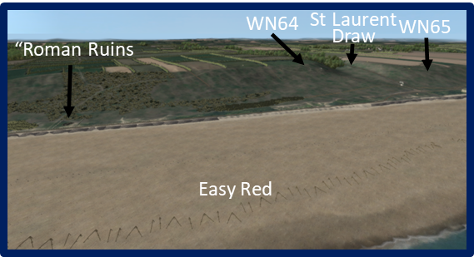

Cue #3

    - BG Willard Wyman, ADC, 1st Infantry Division, 0839. BG Willard Wyman, Assistant Division Commander of the 1st Infantry Division landed at 0839 just to the west of the Roman Ruins. Quickly coming to the same conclusions about the state of the landings as had Cota had farther west, Wyman soon began sending radio reports back to Huebner aboard the USS Ancon. Wyman sent word back to cease landing vehicles and to send more troops to reinforce the 2nd and 1st Battalions on Easy Red. The additional troops coming in early would make a significant difference in the fighting along the beach and inland.

Directions. Have the computer operator pan west (to the right) toward the E1 Exit (St. Laurent Draw) so that WN64 and WN65 can be viewed.

    - Sometime after 0930 Wyman became aware that someone (i.e., Spalding’s section) had neutralized WN64 on the east side of the E1 Exit (St. Laurent Draw). But the exit could not be used until the more formidable WN65 on the west side was eliminated. Within an hour, Wyman’s request was answered with the first of the second wave regiments to land.

Cue #4

    - The Second Wave Regiments – 2nd Battalion, 18th Infantry, 1030. At around 1030, the 2nd Battalion of COL George Smith’s 18th Infantry landed on Easy Red just to the west of the E1 Exit (St. Laurent Draw). Loaded in cumbersome and large LCIs, the battalion was not expected to be making what was essentially an assault landing, yet here they were. Rapidly moving down the gangplanks, the battalion was soon assembling beyond the shingle and preparing to conduct an attack on WN65, another task that was never part of the battalion’s mission. Aided by rifle-toting artillerymen of the 7th Field Artillery Battalion (including its battalion commander), most of the 2nd Battalion began to systematically clear the defenses on the shelf near the mouth of the draw. The troops turned to address the casemate and Tobruks on the bluff.

Cue #5

    - Meanwhile, E Company scaled the bluffs west of WN65 and came in behind the strongpoint. After about an hour-long battle, the nest fell (WN64 was already cleared by Spalding) and the St. Laurent Draw was declared open by noon. However, it would take some hard engineer work before it was suitable for much more than jeeps and light trucks.

Cue #6

    - The Second Wave Regiments – 115th Infantry Regiment, 1100. Half hour after the 2/18th Infantry landed, COL Eugene Slappey’s 115th Infantry, also loaded in LCIs, landed two battalions, one on either side of the Roman Ruins. The regiment wasn’t supposed to come in until much later in the day, but early on, Huebner directed that the regiment be prepared to go in by H+4 (1030). After messages between Wyman and Huebner, the two leaders decided to bring the regiment in at Easy Red. Huebner further directed Cota to take charge of the regiment and clear the bluffs west of the St. Laurent draw (Exit E1), i.e., WN65. However, in a chance meeting on the bluff Wyman informed Slappey that WN65 had just been cleared and then ordered Slappey to take his regiment and clear the town of St. Laurent instead.

Cue #7

    - It would take some time to get his two battalions up to the top so he used both the Spalding / Dawson route as well as the newly opened draw. Slappey started the movement immediately.

Visual: Visual #36, Situation on Omaha Beach, 1200.

  - Summary, 0630-1100. Arguably, by about 0930 on 6 June, the tide of battle had turned on the beaches, although to an observer watching from the water or on the beach, the landings appeared to be failing. However, the reality was that the assault forces had had already created at least three major penetrations to the bluffs and one minor one.

Cue #1

  - Two of the exits (F1 and E1) were open enough to allow some traffic (although these two were the least desirable).

Cue #2

  - At least 6 resistance nests (WN60, WN61, WN64, WN65, WN70, and WN73) had been eliminated or neutralized to the point of being minor irritants.

Cue #3

  - By 1100, Force O had parts of 9 Battalions (parts of about 22 companies) moving up the bluff, on the bluff, or already headed inland. Moreover, more troops were on the way who would follow and expand the penetrations. Clearly, there was still fighting going on at the beaches and on the bluffs, but that fight had been won. The main effort now shifted inland.

Analysis:

- There were a number of what turned out to be wrong assumptions associated with the plan. Of the seven or so wrong assumptions we reviewed earlier which two or three of those do you believe to be the most detrimental or significant in terms of the way D-Day developed on 6 June?

- Aerial Bombardment.

- Naval bombardment.

- Gap Assault Teams.

- DD Tanks.

- Second-Rate Defenders.

- Defenses-One Reinforced Battalion.

- Landing Schedule.

- Massive Numbers.

- Of the various things that the V Corps (and/or its subordinate units at lower levels) did right that day, what two or three things do you believe to be the most significant toward the successes achieved? Consider:

- Small unit leader initiative.

- Naval gunfire support.
- Senior leadership reaction to conditions on the ground.

- Assault unit organization and equipping.

- “Order of march” for assault waves

- In large measure, the fighting on the beaches was successful due to the courage, heroism, and initiative of small unit leaders and individual soldiers stepping up and doing what had to be done under extraordinarily difficult circumstances. As a leader, how would you prepare your soldiers today to function in the same manner?

- FM 3-0 Operations states that:

“Momentum complements and helps maintain the initiative. Momentum reflects a unit’s combat power and the velocity and tempo of its operations. Concentrating combat power at the decisive point, supported by rapid maneuver, places an enemy in a disadvantageous position. Commanders maintain focus and pressure, controlling the tempo of operations while seeking and exploiting opportunities. Maintaining momentum requires continuously assessing the situation and making risk decisions with regard to resourcing the main effort.”

What examples can you point to that shows leaders attempting to maintain momentum and initiative during the fight for the beaches at Omaha?

Stand 3
The Battle Moves Inland (West)

Visuals:

Visual: Visual #37, Inland Objectives.

Orientation:

Once on the bluff, the next immediate objectives for the 1st Infantry Division were the four small towns of Vierville, St. Laurent, Colleville, and le Grand Hameau.

Directions. From the last position, have the computer operator remain in the air and move to the east end of Vierville. Take up a position looking west toward the intersection of the Coast Highway and the road to Vierville Draw (D1 Exit).

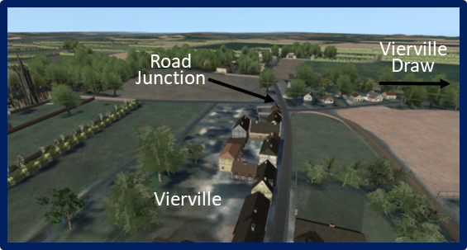

1. Vierville. Vierville was the one of the immediate inland objectives for the 116th Infantry. It was small town which for some reason the Germans chose not to defend. Though there was no significant action in the town, there was to be some heavy fighting to the southeast and west of the village that afternoon.

Directions. Have the computer operator turn left and move to WN 69 and take up a view of the position in the air from the south.

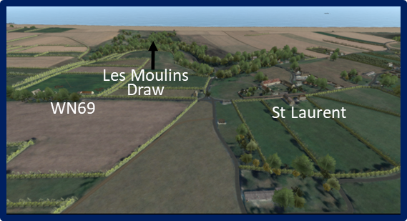

- St. Laurent. St. Laurent was also a 116th Infantry objective.

  - Unlike Vierville, the 352nd Infantry Division chose to set up several strong point positions in St. Laurent. These were arguably the strongest inland defenses immediately behind Omaha Beach. WN69 was largely an indirect fire support position designed to bombard the beachhead area with Nebelwerfer rockets. The position itself was also manned with infantry and at least 3 machine gun positions.

Directions. Have the computer operator slide right and move to St. Laurent proper and take up a view of the church and surrounding areas generally from east to west.

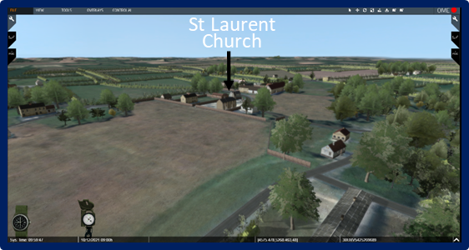

  - The largest defensive position in the town itself was centered on the large church and its immediate church grounds. There were several well-prepared fighting positions covering the approaches to the center of town. The Germans also prepared positions on the flanks of the primary road leading to Formigny which the 916th Grenadiers needed both as a counterattack route, as well as an escape route for the forces in the area in case they were defeated and routed. Elements of the 116th and 115th Infantry would conduct significant fighting in the town as well as in the vicinity of WN69.

Directions. Have the computer operator turn right and move to a position to the south of the west end of Colleville. Initially focus (from a distance) on the area around the church and the farm complex just south of the church; then pan left (west) toward the bivouac area; finally back toward the east end of Colleville and Cabourg.

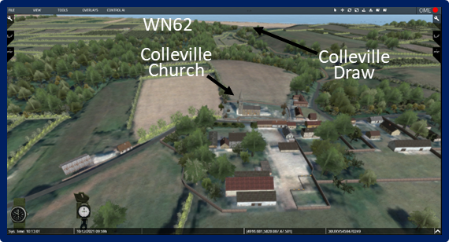

- Colleville. Colleville was a 16th Infantry objective. Like St. Laurent, it possessed a resistance nest (WN63) and several prepared defenses in and around the town. WN63 was not as far along as WN69 at St. Laurent. Besides a concrete underground command post and a bivouac area, there were a few scattered and hastily prepared defense positions in the hedgerows west and north of the town. Within the town, the church steeple held a 5-6 man observation post and another small bivouac area at the eastern end. There were a few positions in the “suburb” of Cabourg and to the northeast.

Directions. Have the computer operator slide right to le Grand Hameau east of Colleville.

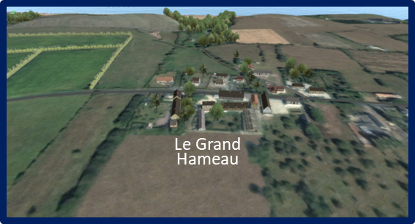

4. Le Grand Hameau. le Grand Hameau was the smallest of the four villages and was also a 16th Infantry objective. The Germans had prepared a few defensive positions in the hedgerows in the area, but it appears that the main role for the village was to be an assembly area and springboard for a counterattack into the Omaha Beach area.

Visual: Visual #38, 352nd Reactions After H-Hour.

Directions. Have the computer operator move to a position to the north of St. Laurent. Focus (from a distance) on the town and the fields to the south of town.

Description:

- Execution. Initial German Reactions after H-Hour.

  - Once it became apparent to Kraiss that this was indeed the actual invasion, he and the 352nd Infantry Division soon faced an almost impossible situation in trying to manage a 45-kilometer front.

  - By 0700, only half hour after the US landings began at Omaha, Kraiss became acutely aware that the 716th Infantry Division defenses in the British sector north of Bayeux were already crumbling.

Cue #1

  - With the 914th’s apparent defensive success in the Carentan area, Kraiss was forced to turn Kampfgruppe Meyer completely around and send it back east to assist the 716th Division.

Cue #2

  - To accomplish this assistance, he further ordered Meyer to conduct a counterattack toward the town of Crépon on the other side of Bayeux. Now out of radio contact, Kampfgruppe Meyer peddled and plodded westward for two more hours because Meyer did not get the message until about 0900.

Cue #3

  - Meyer then turned his weary troops around and started peddling back east. Before long, the kampfgruppe was forced to ditch their bicycles and trucks and move on foot cross-country o try and avoid the roaming American fighter bombers which were now up and looking for targets along the roads.

Cue #4

  - At 0750 Kraiss sent another order to Meyer to send one battalion of the 915th Grenadiers to link up with Goth’s 916th at Surrain.

Cue #5

  - He wanted Goth to use his own 2/916 and Meyer’s 1/915 to conduct a combined counterattack into the Omaha Beachhead no later than 1200. Kraiss also ordered Meyer to begin his attack at Crépon at the same time to give the Allies the impression of a much larger counterattack. Both attacks were to be reinforced with about a dozen Stug III assault guns each from the 352nd Assault Gun Battalion, but ultimately, neither attack would go as planned.

  - By 0900, it seemed to Kraiss and others in the 352nd Division that the Allied invasion effort on Omaha Beach was faltering. Reports from the resistance nests and elsewhere told of heavy enemy casualties and large groups of men stranded on the beach. All that was needed now was an effective counterattack into the beach head area. By 0930, mobile elements from Goth’s 2/916 Grenadiers were moving into the St. Laurent area (these were likely the two reserve companies at which had been at Formigny). Goth’s counterattack force was almost in position. Now all he had to do was wait for KG Meyer to travel back to the other side of Bayeux to conduct its counterattack.

  - Meanwhile, communications throughout the 352nd Infantry Division was being gradually diminished by air attacks and naval gunfire. Nevertheless, as the morning progressed Kraiss received enough information to know that there had indeed been some Allied success in penetrating the beach defenses at Omaha. He now had to do something. So, at about 1030, Kraiss ordered Goth to conduct an early counterattack into the area north of St. Laurent (this was probably in response to the 5th Ranger Battalion’s presence on the bluffs there).

Cue #6

  - In addition, Kraiss ordered most of the 352nd Pioneer Battalion posted near Isigny to head east to Vierville to further reinforce Goth’s 916th Grenadiers, but that battalion would not reach the area until later that afternoon.

- The Capture of Vierville.

Visual: Visual #39, The Capture of Vierville, 0930-2400.

Directions. Have the computer operator move to a position in the air to the area east of Vierville that shows C/116 IN’s approach route. From there move closer to the ground to move through Vierville.

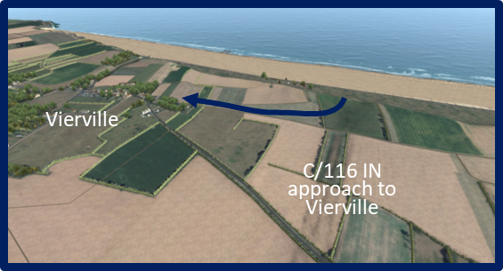

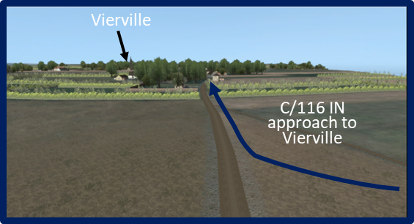

  - C Company, CPT Berthier Hawks, 0900-1100. Once on the high ground between WN68 and WN70, Hawks’ C/116 began to probe inland about 0930.

Cue #1

  - The lead assault team soon found a dirt road leading toward Vierville. The company turned right onto the road. The company arrived on the eastern outskirts Vierville at 1000 but had encountered no opposition. Cota joined the company there as Hawks began to lead his men into the town. Remarkably, the company still encountered no German defenders. The company reached the road junction on the west end of town unmolested and Vierville became the first French town liberated beyond Omaha Beach. The road running north from the junction led into the Vierville Draw. For all intents and purposes, WN71, WN72, and WN73 were now cut-off from the main retreat route to Formigny. C Company took up hasty defense positions there and waited for reinforcements.

Directions. Have the computer operator move back to the east of Vierville in the air looking north to view the bluffs to the east of WN70 where the 5th Ranger Battalion was assembled While in the air, move south over the terrain toward the Coast Highway.

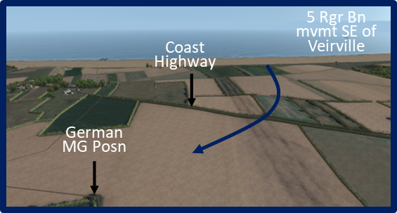

Cues #2 & 3

  - 2nd and 5th Ranger Battalion (Ranger Force C) LTC Max Schneider, 0900-1200. Schneider’s 5th Ranger assembled on the bluff just to the east of Hawks’ C Company where it was soon joined by A and B Companies, 2nd Rangers after they eliminated WN70. Schneider’s original mission was to move through the Vierville Draw and head for Point du Hoc four miles west to link up with Rudder’s 2nd Battalion there.

Cue #4

  - Believing that moving through Vierville would mean a fight, Schneider ordered his men to head east of the town and skirt the built-up area on its south side and move west to the Ormel Farm which was the 5th Ranger Battalion’s rally point.

Directions. Have the computer operator move right to left (toward Vierville). Land behind the last machine gun position and take up a gunner’s view of the field.

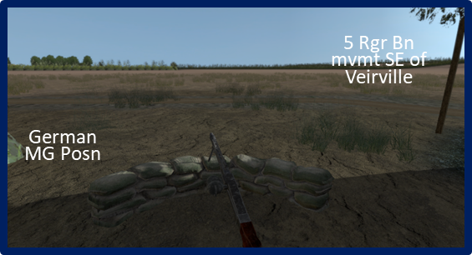

Cue #5

  - The German Defenses. However, as the battalion moved south, it began to run into fierce resistance from stiff German opposition. The opposition was largely provided by Goth’s early counterattack into the area and excellent fields of fire across the fields. A significant firefight developed and the 5th Rangers were prevented from moving south of the town.

Cue #6

  - Schneider was eventually forced to break off and move back through Vierville.

Directions. Have the computer operator move to the east end of Vierville and remaining slightly above the town, follow the 5th Ranger battalion’s route through Vierville to the American defensive positions west of the road intersection.

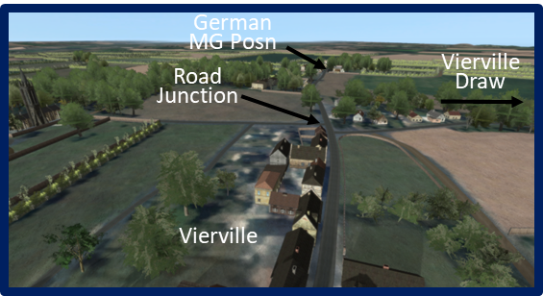
Cue #7

  - The Fight West of Vierville. As the 5th Rangers engaged the Germans in the south, just to the west of Vierville, Cota and Canham showed up at the road junction and directed Hawks to continue movement west along the Coastal Highway. After about a 400-yard advance, the company ran into more stiff resistance. Soon the 5th Rangers’ lead element, B company, arrived and entered the fray. The German positions were well hidden in the hedgerows throughout the area and were too strong for the two companies to overcome and were forced to retreat.

Cues #8 & 9

Directions. Have the computer operator descend to the German machine gun position and once again get a gunner’s view of the terrain from the ground.

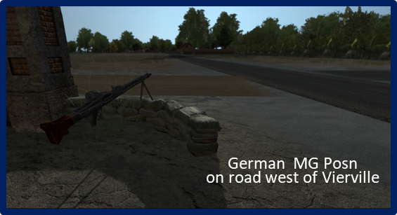

Cue #10

  - As the rest of the 5th Ranger Battalion moved through Vierville, Canham commandeered Schneider’s troops for the effort as well. Since Schneider’s path to Point du Hoc lay through the German defenders, he willingly joined in.

Cue #11

  - Unfortunately, even with the additional firepower, the joint 116th/5th Ranger effort still failed to break through (it may be that the 352nd Pioneer Battalion had arrived by then).

Cue #12

  - About 1500, Canham ordered C/116 and the Rangers to take up defense positions along the hedgerows west of town to wait for reinforcements. They would remain in these positions throughout the evening and into the following morning.

Cue #13

  - Meanwhile, Cota departed and with 4 other men, walked down Vierville draw road with several POWs. After encountering very little resistance, Cota’s party arrived at the anti-tank wall blocking the exit. He immediately began to gather engineers and resources to destroy the wall and open the draw.

- The Fighting at St. Laurent.

Visual: Visual #40, The Fighting at St. Laurent, 1000-2400.

Directions. Have the computer operator ascend to a point above the bluff west of WN66 and focus southward toward the west end of St. Laurent.

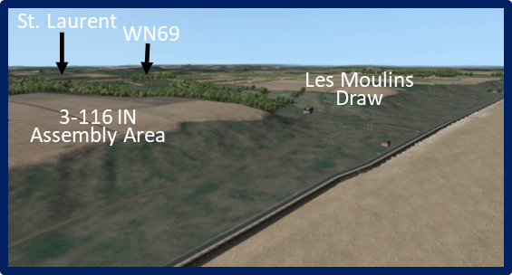

  - Situation. By 1100, Vierville itself was under the control of the 116th Infantry which blocked any further enemy movement on the Coastal Highway east toward St. Laurent. To the east, elements of the 16th Infantry had arrived in the vicinity of Colleville and were about to attack into that village and that unit was now blocking movement on the Coastal Highway west toward St. Laurent.

Cue #1

  - St. Laurent itself sat astride the only road out of the area to the south and which led to the 916th Grenadier Regiment’s headquarters and base of operations at Formigny. Goth was compelled to put up a strong defense in the St. Laurent area to provide both a counterattack avenue to the beach, as well as provide a secure escape route for his soldiers if they were forced to retreat.

Cue #2

  - 3rd Battalion, 116th Infantry, Lt. Col. Lawrence E. Meeks, 0900-2400. By about 0930, 3/116 Infantry was assembled on the bluff east of WN66 generally intact. The battalion, however was very disorganized and in the wrong location to complete its mission which was to move inland several miles to the southwest of St. Laurent. Meeks’ battalion headed southwest across the farm fields and hedgerows toward St. Laurent, but, like the 5th Ranger Battalion, soon ran into German resistance approaching the town.

  - St. Laurent was actually the objective for Bingham’s 2nd Battalion, 116th Infantry. Since St. Laurent was not the 3/116 objective, Meeks intended to move his men west and headed for the upper end of Les Moulins draw where he intended to bypass the town and angle southwest to his objective.

Directions. Have the computer operator descend gradually and move to the southwest toward WN69. Halt above the Les Moulins Draw (D3 Exit) and focus toward WN69.

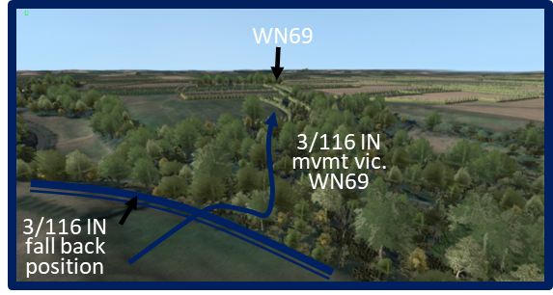

Cue #3

  - As the lead elements crossed the shallow end of the draw near town, they ran into WN69, which was mainly a fire base for ground mounted Nebelwerfers. The defense positions prepared around the nebelwerfer launchers, however, were well sited and effective in stopping the further advance of Meeks’ men.

Cue #4

  - The battalion was forced to fall back to the east side of the draw and set up a hasty defense.

Directions. Have the computer operator ascend slightly and move northeast to a point above the bluff at WN65. At that location pan right toward Les Moulins Draw to view the 2-116 Infantry’s route up to WN65.

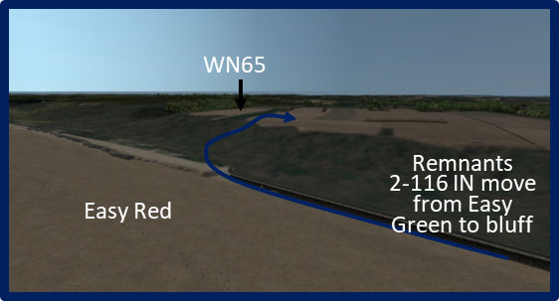

Cue #5

  - 2nd Battalion, 116th Infantry, Maj. Sidney Bingham. Meanwhile, Bingham and 2-116 were still stalled on the beach in front of les Moulins draw. Bingham’s attack on the les Sables d’ Or house bunker had gained no significant advantage, so Bingham gathered up all the men he could find and moved east along the seawall toward the location where 3/116 had climbed the bluffs.

Directions. Have the computer operator pan to the left 180 degrees toward the “Roman Ruins” and move to a point just above the east end of WN64 to view the 115th Infantry’s route up to the bluff.

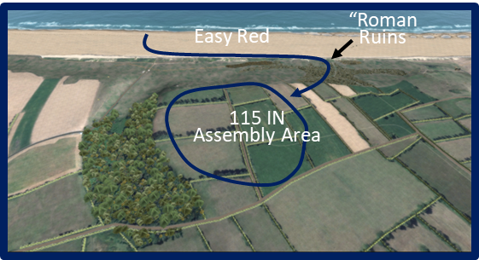

Cue #6

  - 115th Infantry, Col. Eugene N. Slappey, 0930-2400. Having received Wyman’s orders to take St. Laurent, the 1st and 2nd Battalions of the 115th Infantry made their way to the top using the Spalding/Dawson route. Slappey began reorganizing his 2nd Battalion for the main attack once it was assembled on the bluff. It took some time move the battalions around and organized to prepare for the attack.

Cue #7

  - In the meantime, about 1155 the Nebelwerfer batteries at WN69 begin firing at the beaches. Fortunately, US Navy spotters determined their firing positions just west of St. Laurent and soon the USS Thompson moved in close to take them under fire. Little by little the batteries were destroyed or silenced.

Directions. Have the computer operator move to a point above the hedgerows in the vicinity of the 115th Infantry’s assembly area on the bluff. Look slightly southwest at the area of the 2/916th Grenadier’s counterattack.

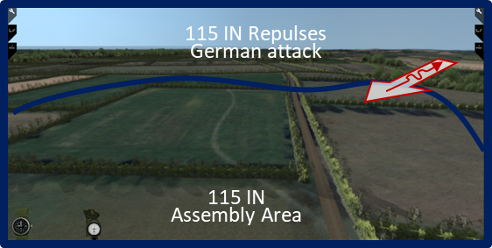

Cue #8

  - German Counterattack. Slowing the 115th’s progress further was a half-hearted counterattack about 1400 by elements of the 2nd Battalion, 916th Grenadiers into the assembly area.

Cue #9

  - The 115th successfully fended off the attack and began its own assault on St. Laurent at 1515.

Cues #10 & 11

  - As the 115th made its approach, the remnants of Bingham’s 2nd Battalion was on the bluff and moved behind the 115th.

Directions. Have the computer operator move west toward St. Laurent. Descend to a point east of the town and follow the 2-115th Infantry’s attack route toward the church complex.

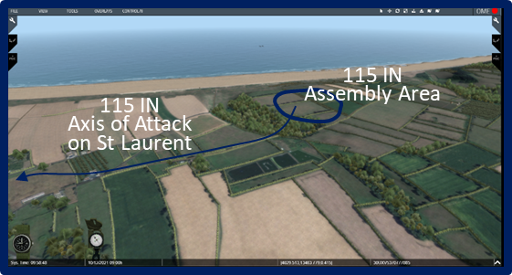

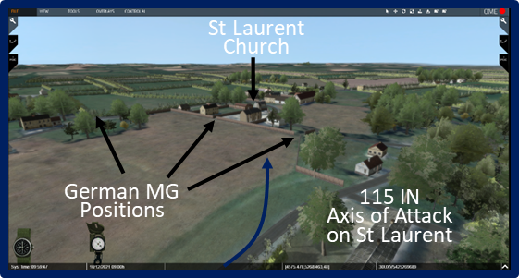

  - The Attack on the Church. The regiment attacked with the 1st Battalion on the left which blocked enemy movement coming from the east and south, and 2nd Battalion, the main effort on the right, would attack to take the town. The regiment passed through the south end of the St. Laurent Draw and advanced across the open fields and hedgerows leading to the town. The lead elements of the 2nd Battalion (E and F Companies) entered the town against no opposition. However, as they approached the center of town, the troops made contact which rapidly escalated into heavy fighting.

Directions. Have the computer operator move to a behind the church wall looking north to east to view the German defenders’ fields of fire.

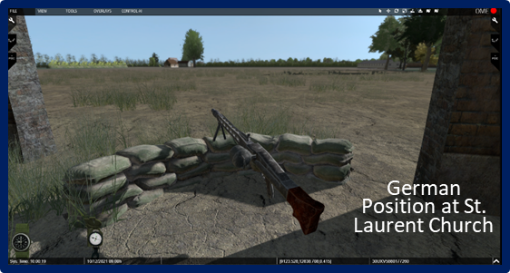

Cue #12

  - The main strongpoint in town was centered on St. Laurent’s church complex which included a stone wall, some outbuildings, and a large stone barn. The walls had been turned into a major defense position and the German defenders had placed at least two machine guns in the steeple and at several other advantageous locations.

  - The Navy’s Support. Observing the machine guns in the church’s spire and surmising that the position was probably also used as an OP for the Nebelwerfers, a JASCO (Joint Assault Signal Company) commander contacted the US Navy and called for fire on the steeple. A destroyer (probably the USS Thompson) shelled the St. Laurent church steeple and destroyed it with the first round.

Directions. Have the computer operator move just to the east of St. Laurent Draw, just south of WN65. Take up a view just east of the two M4 Sherman tanks, and M7 Priest self-propelled artillery vehicles. Move east along the road to St. Laurent until reaching the area of the church in St. Laurent.

Cue #13

  - Evening Actions. At 1830 11 M7 Priests from the 58th Armored Field Artillery and a number of tanks from the 741st Tank Battalion had moved through the E3 Exit (St. Laurent draw) arrived near St. Laurent to support the attack and provided direct fire into fortified stone houses.
Cue #14

  - The 2/115 continued its attack until 2015 when the church complex finally fell. COL Slappey (CO 115) then ordered the 2/115 to sideslip to the east and move south of the town, while the 3/115 took up the attack to clear the rest of the town and the road junction to the west.

Directions. Have the computer operator ascend above the church and pan 180 degrees to the west and focus on the north-south road and road junction that was the German defensive line.

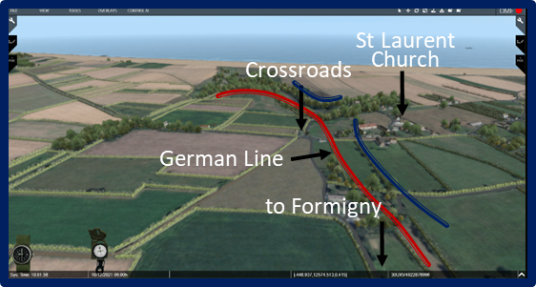

Cue #15

  - Nevertheless, the German forces still held a strong position about 200-300 yards west centered on the road junction leading to Formigny (the escape route) and still held areas south of town and the road junction until sometime on 7 June.

Analysis:

- The fighting in and around the beach defenses was desperate and deadly. What do you see as some of the most difficult challenges facing leaders and soldiers at Omaha Beach as the fighting moved inland? Consider:

Resupply of forces, especially ammunition.

- Moving combat multipliers (tanks, artillery, air defense, etc.) off the beach to support the forces moving forward.

- Command and control.

- Medical evacuation.

- POW management.

- Intelligence acquisition and analysis.

- The assault companies were reorganized from four platoons into six assault sections. What do you see as the pros and cons of such a reorganization for this mission? Do you think the organization was effective once the fighting moved inland? Why or why not?

Stand 4
The Battle Moves Inland (East) & Final Dispositions

Visuals:

Note: At this point the narrative shifts back to the east (CT16) side of Omaha Beach.

Visual: Visual #41, 16th Infantry Situation, 0930.

Directions. Have the computer operator ascend move to a point above the 1-16 Infantry’s assembly area on the bluff. Take up a view toward WN64.

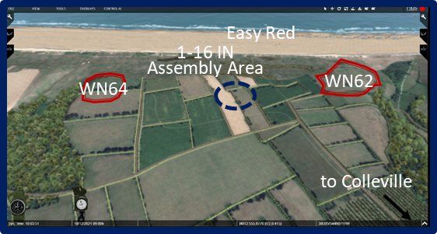

Cue #1

- The Fighting at Colleville. We left the 16th Infantry part of the story at about 0930 that morning with parts of the 3rd Battalion on the bluff north of Cabourg near WN60 . . .

Cue #2

- Dawson’s G Company was en route to Colleville . . .

Cue #3

- . . . the 1st Battalion had just landed and was moving onto the bluff . . .

Cue #4

- And 2LT John Spalding had turned his assault section from E Company west toward WN64.

Visual: Visual #42, Reduction of WN64, 0930-1100.

Directions. Have the computer operator descend move to the point where Spalding and Dawson met that morning. Move up Spalding’s route to the hedgerow short just east of the “construction shack” and take up a gunner’s view of the structure.

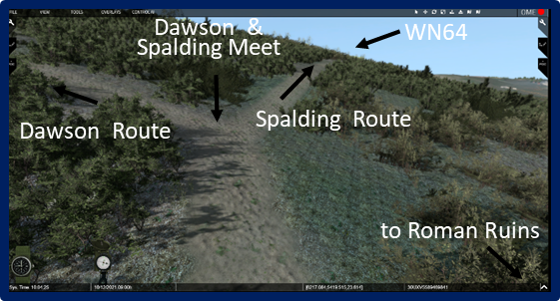

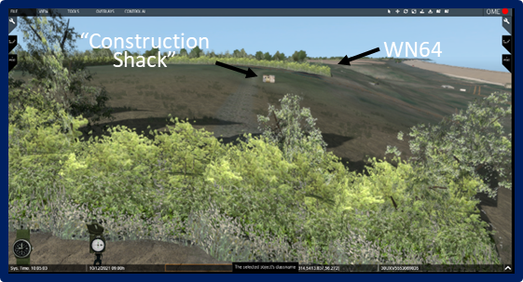

Cue #1

- E Company, CPT Ed Wozenski and 2LT John Spalding.

    - After destroying the initial machine gun position on the bluff . . .

Cue #2

    - Spalding moved his section westward just in from the bluffs.

Cue #3

    - The section first came across a construction shack which it confirmed was undefended by blasting the structure with a bazooka round.

Directions. Have the computer operator descend move west to the trench line where it intersects with the trail. Follow the trench north to the machine gun Tobruk.

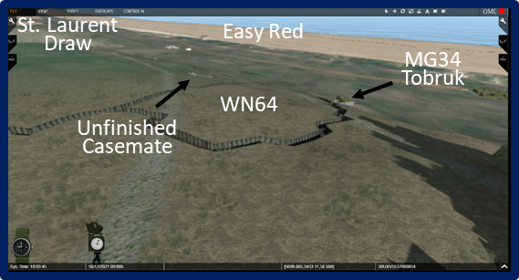

Cue #4

    - Spalding’s men then encountered a network of communication trenches at the eastern edge, the section soon ran into a three-man machine gun position. Fairly quickly, the machine gunner was killed and the other two men, who turned out to be Polish-born soldiers, surrendered.

Directions. Have the computer operator move west from the machine gun Tobruk to the mortar Tobruk and then northwest toward the casemate and the 76.2mm field gun.

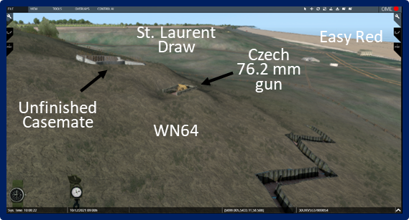

Cue #5

    - The section next captured an unmanned mortar Tobruk and soon approached the edge of the bluff. There, after a brief firefight, Spalding’s men captured the casemate and 76.2mm field gun and eliminated any remaining resistance. At the end of the effort, the section had killed three defenders and captured another 17, most of whom were Polish.

Visual: Visual #43, The Fighting at Colleville, 0930-1100.

Directions. Have the computer operator ascend and move southeast from WN64 to the farmstead along Dawson’s route to the German bivouac area.

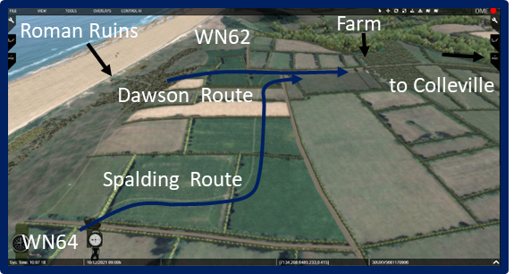

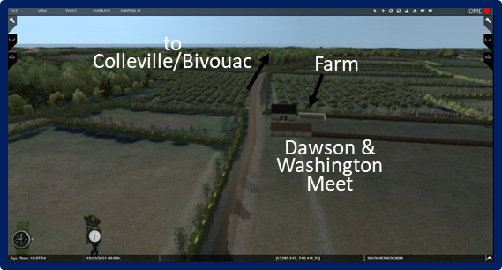

Cue #1

    - After turning over the POWs to some other guards, Spalding headed the 1st Section southeast toward Colleville. En route, Spalding liked up with 1LT Robert Hutch, leader of E Company’s 2nd Assault Section. Hutch took charge of the two sections which now consisted of about 30 men.

    - At about 1045, Hutch and Spalding encountered CPT Wozenski (unclear where this encounter took place) who had now arrived from the bluffs with the remnants of E Company. There Wozenski ordered Hutch and Spalding to continue on to Colleville and link up with MAJ Washington (2nd Battalion XO) at the 2nd Battalion advanced CP which had gone ahead.

Cue #2

- G Company, CPT Joe Dawson. After arriving on the bluff, Dawson headed for Colleville well ahead of Spalding.

Cue #3

- The 1st Battalion assembled on the bluff not long after and began to follow Dawson’s route.

Cue #4

- All except A Company which covered the battalion’s right flank and ran into stiff resistance there.

Cue #5

- MAJ Washington and the advanced CP caught up with Dawson. As they talked, a Frenchman was brought in and told the two men that there were 200 Germans in Colleville.

Cue #6

- Washington didn’t believe the report and sent Dawson and G Company on their way to the town with orders to occupy it.

Visual: Visual #44, The Fighting at Colleville, 0930-1500.

Directions. Have the computer operator move south to the vicinity of the bivouac area/road junction west of Colleville. Descend to the buildings north of the junction and take up a view south toward the bivouac area.

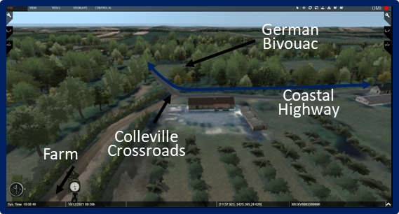

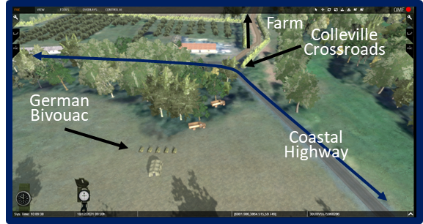

Cue #1

- Fight at the Junction. En route to Colleville, Dawson and G Company ran into a German bivouac area near a road junction west of the town. There, G Company engaged in a fierce firefight which eventually drove the German force away.

Cue #2

Directions. Have the computer operator ascend slightly and move east toward Colleville. Descend to a point just above the bend in the road just west of the church. Focus initially on the church, then on the farm complex on the south side of the road.

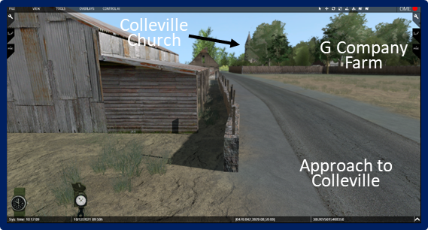

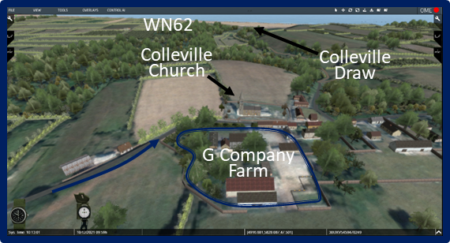

Cue #3

- Fighting in Colleville. By 1300, G Company was approaching Colleville from the west. Most of the company shifted toward a large enclosed farm complex at the northwest side of town across the road from the local church.

Cue #4

- While the company set up positions in the farm complex, Dawson and two men moved across the street to the church itself. Entering the sanctuary, the trio encountered several German soldiers and engaged in a shoot-out inside the building. Though they eliminated the two or three defenders in the sanctuary, there were still a few more up in the steeple.

Cue #5

- The scrap in the church set off a larger firefight within the town almost concurrently which would see-saw back and forth for the rest of the afternoon.

Directions. Have the computer operator move southwest to the “triangle junction.” From there move east past the du Bray Farm to the E Company defensive positions. Take up a view through the hedgerows from behind a machine gun.

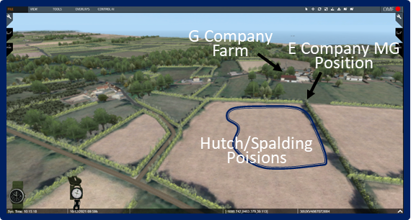

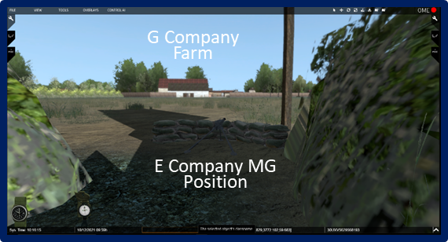

Cue #6

- Reinforcements Arrive. Meanwhile, Wozenski, with the surviving men of three assault sections of E Company (Lieutenants Hutch, Spalding, and now McGourty) arrived in the hedgerows at Washington’s 2nd Battalion CP near the intersection west of Colleville-sur-Mer.

Cue #7

- Hutch and Spalding Extend the Battalion Line. Washington or Wozenski (it’s not clear who) ordered LTs Hutch and Spalding to move their sections to an area south of Colleville. The move was apparently to protect G Company’s right flank. Once the sections moved some distance past the du Bray Farm they encountered some resistance, so they settled into hasty defense positions in the hedgerows.

Cue #8

- Before too long however, enemy elements (who were probably from the lead elements of the 1st Battalion, 915th Grenadiers from Kampfgruppe Meyer), using the hedgerows masterfully, surrounded Spalding and Hutch’s troops.

Cue #9

- Hutch and Spalding Retreat. Once the two officers figured out they and their men were cut off, they considered several options, but decided to try and infiltrate, and if necessary fight, their way out.

Cue #10

- It took time and stealth, but the two sections were able to finally make their way back to the battalion CP.

Cue #11

- The 1st Battalion, 16th Infantry, MAJ Ed Driscoll. Just after the fighting in Colleville broke out, MAJ Ed Driscoll’s 1st Battalion, 16th Infantry, arrived at the intersection near the 2nd Battalion CP about 1330.

Cue #12

- Driscoll moved his battalion through the intersection and headed south about 2 kilometers to a piece of “high ground” southwest of Colleville. The battalion encountered only sporadic contact.

Visual: Visual #45, The Fighting at Colleville, 1400-1800.

Cue #1

- The 2nd Battalion, 18th Infantry, LTC John Williamson. No sooner had Driscoll’s men cleared the intersection, LTC John Williamson’s 2/18 Infantry began passing through the intersection, which was about 1400.

Cue #2

- From there, the battalion headed southeast to occupy 2/16’s original objective. By 1600, Colleville was more or less surrounded on every side except due east.

Directions. Have the computer operator ascend and move north to the west end of Colleville in the vicinity of the church/farm complex. Take up a view looking generally east toward the 1/915 GR’s approach into town.

- The fighting around Colleville at this point was part of 2/916 GR’s main counterattack (which actually started about 1400 in this area).

Cue #3

- The 2/916 GR was soon supported by elements of the 1/915 GR arriving at the town and by elements of the 726th IN in the vicinity of WN60 battling against CPT Richmond and the 3rd Battalion, 16th Infantry.

Visual: Visual #46, 352nd Infantry Division Reactions, 1400-2100.

        - 352nd Infantry Division Reactions, 1400-2100.

Cue #1

        - Kampfgruppe Meyer, 1400-1700. Meanwhile at 1400 COL Meyer was still having a difficult time trying to get his kampfgruppe into position for the counterattack on Crepon (northeast of Bayeaux). Kraiss contacted Meyer and asked if he was ready to conduct his attack. Meyer explained that his command was still strung out on the road due to fighter-bomber attacks and was not yet ready. Kraiss nevertheless ordered Meyer to start the attack at 1430 with whatever forces he had at the time.

Cue #2

        - No sooner did Meyer get off the radio when his lead force, the 352nd Fusilier Battalion, was attacked by elements of the British 50th Northumberland Division. Fortunately for Meyer, 13 Stug IIIs from the 352nd Assault Gun Battalion arrived just in time to support the Fusiliers and drove the British forces back.

        - British POWs told Meyer that additional reinforcements were on the way and that the attacks would continue once they arrived. That tidbit, along with the strength of the initial British attack, convinced Meyer to break off the action and fight his way west to link up with Goth’s 916th Grenadiers to keep from being cut off. Kraiss reluctantly concurred.

Cue #3

        - Meyer turned his kampfgruppe west with the 2/915th GR leading.

Cue #4

        - Before the entire kampfgruppe could get on the road, however, the British attacked again and largely overran the 352nd Fusilier Battalion and Meyer was killed in action.

Cue #5

        - The 2/915th GR arrived at Colleville about 1710 and joined in the fight against the 16th Infantry elements in that vicinity and le Grand Hameau.

Visual: Visual #47, The Fighting at Colleville, 1400-2100.

Directions. Have the computer operator descend to the west of the church near the rubbled wall and replicate the photo.

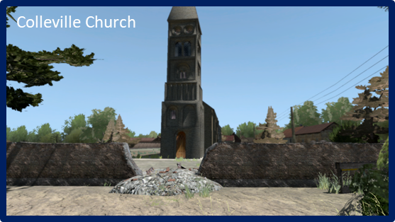

Cue #1

- Evening Actions. With the arrival of the 2/915th GR, the fighting in and around Colleville continued to be heavy into the evening. Although by this time, the Germans who had been fighting from the church steeple had been killed or driven off, the US Navy did not know it. In fact, the members of the Naval Gunfire Support team which had landed with the 2nd Battalion had been killed or wounded in the landings so there had been no communications with the Navy to let them know that there were friendly troops in the town.

Cue #2

- At about 1855, the destroyer USS Hardin fired 73 rounds into Colleville and at the church steeple. The Hardin successfully brought down the steeple and killed or wounded at least 8 soldiers in G Company. By dark, the 2nd Battalion (mainly G Company) held the western quarter of Colleville. There would be several small firefights in and near the village throughout the hours of darkness that night, but the lines would remain the way they were at dark until the morning of 7 June.

- The Capture of le Grand Hameau.

Visual: Visual #48, The First Two Patrols, 1030-1300.

Directions. Have the computer operator ascend and move to a position south of Cabourg looking toward thethe 3rd Battalion hasty defenses near WN 60. Take up a view looking generally between Cabourg and le Grand Hameau.

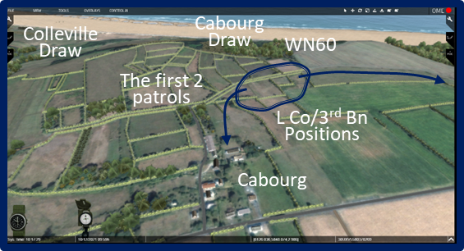

The First Two Patrols, 1030-1300

  - The 3rd Battalion, 16th Infantry, CPT Kimball Richmond (acting).

            - L Company, 1LT Robert Cutler, 0900-1030. As G Company and other elements of the 2nd Battalion were moving toward Colleville, to the northeast of the town, Cutler’s L Company was establishing its hasty defense on the bluff and clearing out WN60.

Directions. Have the computer operator move to a position near the north end of Cabourg looking south.

Cue #1

            - The First Patrol. Before Richmond’s arrival to take charge of the 3rd Battalion elements there, Cutler set out two patrols; one was sent south toward Cabourg and the other toward le Grand Hameau.

Cue #2

            - The first patrol, consisting of only 3 men, did not return because it was soon surrounded and captured as it entered the little village. Overnight, the patrol leader, PFC Lawrence Mielander, who spoke fluent German, convinced his captors that their situation was hopeless. Knowing that two American infantry battalions were now (that night) situated between them and the 916th GR headquarters helped to reinforce the impression.

Cue #3

            - The next morning Mielander and his two buddies marched 52 German POWs into the 2/18 Infantry lines.

Directions. Have the computer operator pan slightly to the right to view Davis’ route to le Grand Hameau.

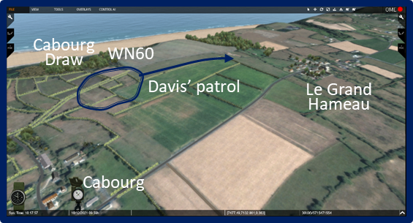

Cue #4

            - The Second Patrol. The second patrol sent by Cutler consisted of 4 men under SGT Burrton Davis. Cutler sent Davis’ patrol toward le Grand Hameau to seek out if and where any German defenses were located and determine the best avenue of approach to the village. Near the town, Davis stopped to talk with a local Frenchman when suddenly a German soldier came walking down the dirt road. One of Davis’ men shot the unwary trooper and suddenly the hedgerows came alive with the shouts of many German soldiers as they scrambled to take up positions and fight. Initially, there was no return fire, only insults in broken English, laughing, and other taunts from the German troops. As the insults continued, it became apparent to Davis and his men that the Germans were obviously drunk.

Cue #5

            - After a short interval of the shouting, one of the Germans finally opened fire which was followed by other bursts of gunfire.

Cue #6

            - Davis decided it was time to leave. He had the information he needed and returned to reported it to Cutler.

Directions. Have the computer operator move to a position south of the 3rd Battalion hasty defenses near WN 60. Take up a view looking generally north toward the Cabourg Draw.

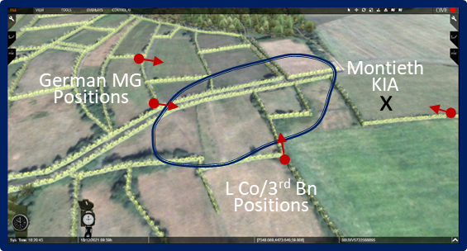

Cue #7

            - Richmond Arrives. While Davis was out on his patrol, sometime between noon and 1300, CPT Kimball Richmond arrived with the remnants of I Company and took charge of all 3rd Battalion troops and attachments there. The “battalion” now consisted of about 104 men including those of E/116th Infantry and a few others.

Visual: Visual #49, German Counterattack at Le Grand Hameau, 1430-1700.

Cue #1

            - The German Counterattack @1430. Sometime after Davis’ patrol report, the 3rd Battalion came under a counterattack by elements of the 2/916th GR and 726th GR (which may have been reinforced with elements of the 1/915th at this point).

Cue #2

            - The heaviest part of the attack was from the direction of le Grand Hameau, but other elements, using the hedgerows, gained the battalion’s rear from the direction of Cabourg-Colleville. The attack was supported by machine gun and mortar fire and its objective in this area was to destroy the 3rd Battalion, regain the positions at WN60 and WN61, and keep the F1 and E3 exits closed. Before long drunken shouts for the Americans to surrender came from virtually all directions except toward the beach.

Directions. Have the computer operator descend to the ground at Monteith’s 1st Position (see visual #49). Move west to Monteith’s 2nd Position.

Cue #3

            - 1LT Jimmie Monteith. As the battalion desperately fought off the probes and attacks around its perimeter. 1LT Jimmie Monteith once again went into action. Spotting a German machine gun position on the west side of the perimeter, Monteith made his way to within 40 yards of the position and fired a rifle grenade. The first shot missed, but the second hit squarely on target knocking out the gun.

Directions. Have the computer move to Monteith’s 3rd Position.

Cue #4

            - Hearing the chatter of another machine gun position to the south, the lieutenant made his way close to that position. He came so close in fact that he was able to lob hand grenades to destroy that position.

Directions. Have the computer move to Monteith’s 4th Position.

Cue #5

            - Hearing a third gun farther east, Monteith made his way toward that gun as well. Crossing a 200-yard open field somehow without drawing fire, he launched rifle grenades at that gun. It isn’t clear if the destroyed the gun or drove off the crew, but the firing ceased.

Directions. Have the computer move to Monteith’s Final Position.

Cue #6

            - Trying to move back to his original position along a hedgerow, he found part of his section under heavy fire from still another machine gun. As he started across another open field, his luck ran out. In a burst of machine gun fire, he was instantly killed as he ran.

Cue #7

            - For his actions, Monteith was later awarded the Medal of Honor.

Cue #8

            - By about 1700, the German forces retreated and the counterattack had failed. The 3rd Battalion sustained a number more casualties, but they had clearly defeated the German efforts.

Cue #9

Visual: Visual #50, The Capture of Le Grand Hameau, 1730-2400.

Directions. Have the computer operator ascend and follow Davis’ route into le Grand Hameau. Take up a view looking east.

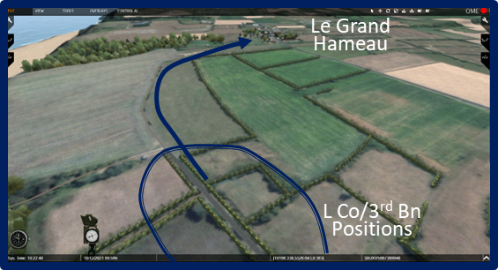

Cue #1

            - The Third Patrol and Capture of le Grand Hameau. About 1730, Richmond sent a third patrol toward le Grand Hameau under 1LT Williams. SGT Davis, who had led the earlier patrol, led this effort by moving first with a small section along the route he had determined earlier.

Directions. Have the computer operator follow Williams’ route into le Grand Hameau. Take up a view looking generally east at the wrecked German staff car at the intersection.

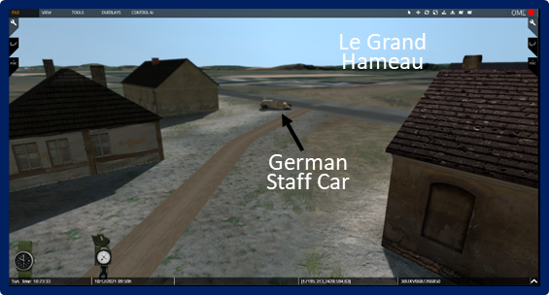

Cue #2

            - Davis was followed by a larger group under Williams, who was then followed by Richmond with the rest of his command. Surprisingly, the patrols encountered almost no resistance. Davis moved into the town and reported that the enemy was no longer present and the rest of the battalion soon followed. Not long after the village was secured, alert troops captured a German staff car with maps and documents, as well as 2 additional scout cars. Within a short period of time, LTC Charles Horner, the battalion commander was finally able to link up with his command (he had been landed in the vicinity of WN62 and had to make his way across the Colleville draw with the battalion CP against sporadic German resistance during the day).

Cue #3

            - Around dark, a company of tanks from the 743rd Tank Battalion arrived from the F1 Exit to help hold the position. Colleville itself was now virtually surrounded.j

- Situation End of D-Day.

Directions. Have the computer operator start with a view of Omaha Beach in the air positioned about center sector (boundary between Easy Green and Easy Red beaches) and looking north out to sea (generally replicate the visual).

Visual: Visual #51, Situation 2400, 6 June 1944.

  - Limits of Advance on D-Day. Given the unexpectedly strong resistance at Omaha Beach on D-Day, it was no wonder that the V Corps was unable to fulfill its D-Day objectives.

Cue #1
  - In fact, the corps was unable to clear the beachhead area even out to the Beachhead Maintenance Line. The location of the regiments/battalions and CPs by midnight were:
Cue #2
    - 2nd and 5th Ranger Battalions (west of Vierville)
Cue #3
    - Elements of 1/116th Infantry (West and south of Vierville)
Cue #4
    - 3/116th Infantry in St. Laurent
Cue #5
    - 115th Infantry (South and east of St. Laurent)
Cue #6
    - 26th Infantry east of St. Laurent and north of Colleville.
Cue #7
    - 1/18th Infantry and 3/18 Infantry (Along the Coastal Highway between St. Laurent and Colleville).

Cue #8
    - 2/18th Infantry (Southeast of Colleville)

Cue #9
    - 1/16th Infantry (South of the Coastal Highway)
    - 2/16th Infantry (Western quarter of Colleville to the Coastal Highway Junction)
    - 3/16th Infantry (le Grand Hameau)

  - Status of the Draws. On the other hand, by dark (@2100) all five exits were open and traffic (mostly tanks and artillery) was moving into assembly areas (open fields on the bluffs) to prepare for offensive operations on the morning of 7 June.

Cue #10
        - Exit D1 (Vierville Draw). AT wall blown 1500; opened @2100. (First unit through: Co/743rd Tank Bn)
Cue #11
        - Exit D3 (Les Moulins Draw). Engineer work started 1900; partially opened for traffic by 2030.
Cue #12
        - Exit E1 (St. Laurent Draw). Engineer work started 1230; opened for traffic @1530. (First unit through: a battery from the 58th Armd FA Bn)
Cue #13
        - Exit E3 (Colleville Draw). Engineer work started 2000; opened for traffic 0100. (First unit through: B Company, 745th Tank Bn)
Cue #14
        - Exit F1 (Cabourg Draw). Engineer work started 1630; opened for traffic 2030. (First unit through: a company from the 741st Tank Bn)

  - D-Day Casualties in the Omaha Area.

Visual: Visual #52, Omaha Beach, US Army Casualties and Losses, 6 June 1944.

            - US Casualties. By the end of D-Day, the V Corps had sustained between 2,400 and 3,000 casualties in all units. The lion’s share of these losses was borne by the two assault regiments, the 16th and 116th Infantry. The 16th Infantry lost between 900 and 1,000 men; the 116th lost something over 1,000. Key equipment losses included:

              - 50 tanks
              - 26 artillery pieces
              - 50 landing craft
              - 10 larger vessels

            - German Casualties. Of the approximately 12,000 men in the 352nd Infantry Division on 6 June 1944, about 1,200 (10%) of them were killed, wounded, or captured on D-Day. The vast majority of those casualties were sustained in the fighting at and near Omaha Beach, as well as those suffered by Kampfgruppe Meyer. It’s not clear how many of the 7,800 men of the 716th Infantry Division were casualties, though the percentage of losses were bound to be more than that of the 352nd Infantry Division. Given that a large percentage of the 716th’s troops were manning the beach defenses, those troops’ ability to escape the resistance nests before being killed, wounded or captured, was far less than that of the mobile formations farther from the beach. A “guesstimate” of 20% losses (@1500 men) is not unreasonable.

- Summary of advance to original D-Day line (7-9 June)

Visual: Visual #53, V Corps D-Day Objectives, 6 June 1944.

Cue #1
  - This visual recaps the V Corps objectives for D-Day. The medium blue dashed line represents the planned D-Day Maintenance Line. The thicker dark blue line was where planners thought the V Corps would end up by the end of D-Day.

Visual: V Corps Advance to the D-Day Objective Line, 6-9 June 1944.

Cue #1

  - Despite the heavy resistance in the Omaha area, the V Corps was able to land about 34,000 of the planned 55,000 troops on D-Day. Once the exits were opened, and the V Corps began its advance farther inland on the morning of 7 June, tens of thousands more soon followed to begin the roll back of the Third Reich.

  - By the end of the following day (7 June), the 1st Infantry Division had advanced beyond the original Maintenance Line creating enough room for the incoming 2nd Infantry Division and thousands more troops and vehicles. On the west, Horner’s 3rd Battalion, 16th Infantry effected the link up with the British 50th Northumberland Division at Huppain. Concurrently, The 29th Infantry Division pushed west toward Isigny to conduct the link up with the VII Corps units in that direction.

  - By the end of 8 June both the 1st Infantry Division and the 29th Infantry Division had generally reached the original D-Day objective line and the V Corps prepared to put the 2nd Infantry Division into the line.

  - Back at the Omaha Beach exits, tens of thousands more men and vehicles were coming ashore.

  - Despite the early setbacks and unexpected level of resistance in the Omaha Beach area, the bottom line was that the landings at Omaha succeeded due largely to the individual bravery of soldiers and small unit leaders to overcome incorrect planning assumptions and other challenges and for which no one had planned or anticipated. The courage, sacrifice, and initiative of these men made it possible for the operations at Omaha Beach to ultimately succeed and help begin the roll back of the Third Reich.

Analysis:

- What do you see as the 352nd Infantry Division’s most important success in the Omaha Beach area on D-day? Consider:

- The defense of WN62.

- The damage inflicted by the beach resistance nests.

- The German beach/bluff obstacle plan

- What do you think were the critical factors contributing to the 352nd Infantry Division’s ultimate failure? Consider:

- The division’s area of operations.

- Kraiss’s use of his reserves (especially Kampfgruppe Meyer).

- Available combat power.

- The performance of the Luftwaffe in close air support.

- What do you see as the most important aspects of combined and joint operations at Omaha Beach on D-Day? Consider:

- The British navy’s role

- The US Navy’s role

- The role of the Army Air Force at Omaha Beach and its environs.

Integration

I. As discussed elsewhere, a Staff Ride consists of three phases.

A. The first phase is “The Preliminary Study Phase.” This phase is conducted before the visit to the battlefield and prepares the student for effective participation in the staff ride.

B. The second phase is “The Field Study Phase.” This phase is conducted with the battlefield terrain (as presented through the computer in a virtual staff ride) and better allows students to understand historical events through analysis of the actual terrain.

C. The third and final phase of a Staff Ride is “The Integration Phase.” No Staff Ride is complete without an Integration Phase, and it is a critical event in order for the students to understand what happened, why it happened, and most importantly, what can be to be learned from the study of the battle or campaign.

II. There are several factors that the Staff Ride leader should consider when planning for and conducting the Integration Phase.

A. First and foremost, the leader must work with the organization which is participating in the ride and select a time and location for the Integration Session.

B. For a VSR, the most common location for the Integration Session is the classroom after the Field Phase is complete.

C. It is recommended that, when possible, students have some time for personal reflection and thought before the Integration Phase.

D. In some case, the Integration Phase may be conducted the day after the Field Study Phase ends.

III. The Instructor should organize the Integration Phase based on the unit, time available, and training objectives.

A. It is important to keep in mind that the Integration Phase is NOT an AAR of the ride itself (i.e., ways to improve the ride). While it is useful to seek constructive criticism in order to continue to improve the ride, this should be done at another time, or perhaps with written AAR comments.

B. Instead the Integration session is used for the staff ride participants to integrate their preliminary study with the field work in order to gain insights that are relevant to their current duties and enhance their professional development.

C. Whatever method the instructor chooses to employ to generate discussion, the most important thing to remember is that the participants should do the majority of the talking.

D. One method that often produces a fruitful Integration Phase is to conduct the session in three parts, based on three broad questions. Sometimes, the leader need only present the general question and let others carry the conversation, or the leader may have to ask more follow-up questions to prod the discussion.

1. What aspects (ideas, opinions) of the campaign had you developed in the Preliminary Study Phase that changed because of your study of the ground?

a. This is a crucial question because seeing the terrain is central to a staff ride, otherwise the campaign could simply be studied in the classroom. Of course, students may develop a wide range of answers based on their personal study and what they observed in the field.

b. Some of the more popular aspects of the discussion of terrain for Omaha Beach include the runnels, the shingle and sea wall, the obstacle belts, the bluffs, hedgerows, and fields of fire on the beach and inland.

c. The instructor can add: Did seeing the terrain alter your opinion of any of the leaders and their decisions?

2. What aspects of warfare have changed and what aspects have remained the same since the landings at Omaha Beach?

a. The answers to the “changed” aspect will probably seem more obvious to the modern military professional and often will be related to technology. This may include changes in weapons, transportation systems, communications, cyber, drones, information operations tools, and numerous other pieces of equipment.

b. The aspects that have “remained the same” may not seem as numerous at first, but the students will often build on some initial answers and find a lot of good items. The role of personalities, command relationships, the importance of logistics, the need for strong, positive leadership, and an ability to motivate soldiers, soldier/leader initiative, the importance of operational maneuver, determination, courage, and fear are just some of the items of warfare that seem to have changed little since 1944.

c. Depending on the group, you may want to ask a few more focused questions. For example, if you have a logistics unit as participants, you can ask what aspects of logistics have changed and what aspects have remained the same?

3. What insights can the modern military professional gain from the D-Day landings at Omaha Beach that are relevant today? Clearly, the participants can take this discussion into a vast number of arenas.

a. Once again, the type of unit participating in the Staff Ride might help to guide the discussion. For example, a military intelligence unit might focus the commander’s situational awareness, intelligence gathering, and the importance of reconnaissance.

b. Modern frameworks such as Warfighting Functions and the Elements of the Operational Art can be used to help prompt the discussion.

4. The three suggested Integration Phase questions are meant to aid in sparking discussion, not to provide hard and fast “rules” of warfare. The Instructor should always be ready for the participants to develop their own answers, and thus be prepared to let the discussion roam many different paths. With that in mind, below is a brief list of popular topics in reference to the D-Day landings. It is just a short starter for a many other possibilities.

• Balancing the tactical fight with the larger operational goals of the campaign.
• The potential cost in lives involved in operations that don’t go as planned.
• Joint, combined (i.e., allied contributions), and combined arms aspcts of such operations.
• Training, doctrine and equipment needed for forced entry operations.
• Evaluate leadership and the various levels in light of Mission Command.

